

**COSC 5369 Graduate Project**

**Project Title:**

Med Patient Portal Web Application

A Report

Presented to:

The Faculty of the College of Graduate Studies

Lamar University

In Partial Fulfillment

Of the Requirements for the Degree

Master of Computer Science

By

Bhargav Abhinay Reddy

Venkata Harun Ganta

Praveen Raja Neerukonda

Med Patient Portal Web Application

Prepared by: Group_ Approved By:

Bhargav Abhinay Reddy ____________________

Venkata Harun Ganta Dr. Timothy Roden

Praveen Raja Neerukonda Supervisor Professor

_____________________

Dr. Makki

Committee Member

_____________________

Dr. Bo Sun

Committee Member

________________________

Dr. Jing Zhang

Chair, Department of Computer Science

**Acknowledgement**

In the preparation of the report, under submission, the learned guidance that we received from our project supervisor Dr. Timothy Roden, Department Chair and Associate Professor, Lamar University has been a constant source of inspiration to us. The keen interest he took in making careful observations of the program and results, time-to-time progress of our project work helped us a lot. It is with profound sense of humility we express deep indebtedness to him for his supreme guidance.

We are grateful to the members of faculty in the Department of Computer Science, Lamar University for their encouragement and valuable suggestions. In this context, we cannot fail to express gratitude to Dr. Makki and Dr. Bo Sun for their valuable guidance.

Contents

**ABSTRACT:**

The healthcare sector must innovate and adapt in this age of rapid technology innovation to fulfill the changing needs of both patients and healthcare professionals.

The architecture and operation of a cutting-edge Hospital Management System (HMS) web application, created to transform hospital administration and improve patient care, are explained in this abstract.

For hospitals and healthcare organizations looking to optimize operations across multiple departments and processes, the HMS online application is a cutting-edge solution. By prioritizing accessibility and usability, the platform empowers healthcare providers and administrative personnel by ensuring a seamless experience for users with varying technical backgrounds.

The extensive patient management interface of the HMS web application facilitates the effective tracking of patient health records, and the online appointment administration and scheduling is smooth.

In addition, the system has a staff management interface that makes it easier to keep track of personnel data and other necessary transactions, which improves resource allocation and workforce management.

A strong pharmacy management module in the HMS online application also helps to improve medication management and patient safety by enabling the scheduling of prescriptions and tracking delivery status.

The system uses strict methods to protect patient data and mitigate vulnerabilities, guaranteeing confidentiality and regulatory conformance. Security and compliance are of utmost importance.

Additionally, the platform streamlines administrative activities and improves operational efficiency with capabilities like bill payment, insurance claim tracking, and financial operations.

The HMS web application encourages community involvement and social responsibility beyond its basic features by funding humanitarian endeavors. and fundraising events, encouraging a spirit of altruism and support for worthy causes.

The HMS online application empowers healthcare practitioners to provide high-quality treatment effectively by offering a consistent and user-friendly experience across multiple platforms thanks to its responsive design and simple interface.

In conclusion, the HMS web application is a revolutionary tool for bringing hospital management practices up to date. It helps healthcare organizations prioritize patient-centric care and operational excellence while simultaneously adapting to the demands of a quickly changing healthcare environment.

The Hospital Management System (HMS) is a feature-rich web application that integrates many departments and processes to optimize a healthcare institution's operations. The features of this system include recording insurance claims, managing workers, managing pharmacies, managing patients, managing security, handling financial transactions, and supporting philanthropic activities. HMS guarantees regulatory compliance, improves patient care, and makes efficient healthcare delivery possible by offering a centralized platform.

**INTRODUCTION:**

The vital duty of preserving and improving human health falls to the healthcare sector, which is situated at the nexus of creativity and compassion. To guarantee that patients receive high-quality care while maximizing operational efficiency in this ever-changing environment, healthcare facilities must be managed effectively.

A key instrument in this effort is the Hospital Management System (HMS), which provides a comprehensive way to simplify the intricate workings of healthcare facilities.

The Hospital Management System, a web application, is designed to integrate multiple departments and processes in a healthcare facility. These departments include staff administration, pharmacy management, patient management, security compliance, insurance claim tracking, financial processes, and support for charitable endeavors. Healthcare companies can unify their activities on a single platform thanks to this comprehensive strategy.

In its most basic form, the Hospital Management System acts as the digital spine of healthcare facilities, acting as a single point of contact for all vital data and resources.

Healthcare organizations can better meet the changing requirements and expectations of both patients and regulatory bodies by utilizing HMS, which provides a unified platform that streamlines healthcare delivery, improves patient care, and assures regulatory compliance.

This introduction delves into the critical role that the Hospital Management System plays in contemporary hospital administration, emphasizing the value of this system in streamlining operational procedures, enhancing patient outcomes, and promoting an innovative and high-achieving culture in healthcare delivery.

Healthcare companies are empowered by HMS's extensive feature set to manage the complicated healthcare landscape confidently, resiliently, and compassionately.

**KEYWORDS:**

* Robust Security measures.
* Scalable Architecture.
* Agile Development methodology.
* Responsive Angular App.
* Single Page Application.
* Angular Guards Protected.
* Spring Boot Endpoints.

1. **PURPOSE OF THIS PROJECT:**

A medical patient portal online application's objective is to give patients safe access to their test results, medical records, appointment booking, prescription refills, provider communication, and other services linked to healthcare. By enabling patients to manage their health information and interactions with healthcare professionals online, this digital platform improves patient involvement, convenience, and the overall healthcare experience. It can also facilitate communication between patients and their healthcare team and expedite administrative procedures for healthcare providers.

1. **WHY ARE YOU INTERESTED IN DOING IT?**

**MOTIVATION:**

The choice to build a web bank application with Angular and Spring Boot stems from the need to offer a reliable, effective, and modern banking experience. With its dynamic features and two-way data binding, Angular serves as the front-end framework, providing a user interface that is both responsive and captivating. The goal is to take advantage of Angular's versatility to create a seamless and easy-to-use user interface that lets customers easily manage their accounts online.

Designing a Hospital Management System (HMS) is an ambitious endeavor aimed at transforming healthcare delivery and improving patient care. Here's some motivation to inspire your journey, along with a breakdown of key features:

* **Enhancing Healthcare Delivery:** An HMS is designed to streamline and optimize various departments within a hospital, including Administrative, Clinical, Medical, Laboratory, and Operational Processes. By integrating these departments into a cohesive system, hospitals can improve efficiency, reduce errors, and enhance overall healthcare delivery.
* **Empowering Patients:** The Patient Management Portal is a cornerstone feature of an HMS, allowing patients to access and track their healthcare information online. From viewing medical records to scheduling appointments and managing prescriptions, this portal empowers patients to take an active role in their healthcare journey.
* **Improving Appointment Management:** Patients can schedule and manage appointments online, reducing wait times and improving access to care. This feature not only enhances convenience for patients but also helps hospitals optimize their appointment scheduling processes.
* **Efficient Staff Management:** The Staff Management portal enables hospitals to track employee information, schedules, and transactions. By centralizing staff management processes, hospitals can ensure efficient staffing levels, improve communication among staff members, and streamline administrative tasks.
* **Effective Pharmacy Management:** Pharmacy Management features allow hospitals to schedule medications and track delivery processes. This ensures timely and accurate medication administration, improves patient safety, and enhances overall pharmacy operations.
* **Ensuring Security and Compliance:** Security and compliance are paramount in healthcare, and an HMS includes robust features to protect patient data and mitigate risks. By implementing encryption, access controls, and compliance protocols, hospitals can safeguard sensitive information and ensure regulatory compliance.
* **Streamlining Insurance Claim Processes:** The HMS facilitates online tracking of insurance claims, simplifying the process for patients and healthcare providers alike. This feature reduces administrative burden, accelerates reimbursement processes, and improves overall revenue cycle management.
* **Facilitating Financial Transactions:** Hospitals can streamline bill payment and financial processes through the HMS, allowing patients to make payments online and access financial information conveniently. This feature enhances financial transparency, reduces billing errors, and improves patient satisfaction.

1. **WHAT ARE THE COMPUTER SCIENCE PRINCIPLES INVOLVED?**

The entire project is divided into two applications involving both Frontend (Graphical User Interface) and its Backend Service.

1. **Front End:**

HTML

CSS

JavaScript

TypeScript

Angular

1. **Backend:**

J2EE (Java Spring Boot)

1. **Database:**

MySQL

1. **Briefly describe what methods you have used. Give an overview of what has been done.**

The overview of the methods used in developing the medical patient portal web application:

1. Requirements Gathering
2. System Design
3. Database Design
4. FrontEnd Development
5. Backend Development
6. Providing Security (Authentication & Authorization)
7. Api Testing
8. End To End testing.

Supporting Charitable Endeavors: The HMS can also serve as a platform for supporting charitable causes and facilitating donations. By integrating donation and charity features directly into the website, hospitals can engage with the community, support worthy causes, and make a positive impact beyond healthcare delivery.

**RELATED WORK:**

In related work for developing this Web Application Med patient Portal, we have done a literature survey on some related info:

1. Existing Patient Portals: Review features, interfaces, security of other portals.
2. Research Papers: Analyze academic studies on patient portals, healthcare informatics, and user experience.
3. Industry Standards: Study guidelines from organizations like HIMSS, ONC.
4. Regulatory Compliance: Ensure compliance with HIPAA and other regulations for data privacy and security.
5. User Feedback: Consider case studies and feedback from existing portal users.
6. Technological Trends: Stay updated on emerging tech like blockchain, telehealth integration, and interoperability standards.

**SYSTEM ARCHITECTURE:**

The application flow for a web application built using Angular as the front-end framework, Spring Boot as the back-end framework, and MySQL as the database using the JDBC Template for data access.

1. **Client-Side Flow (Angular SPA):**

* The user interacts with the Angular Single Page Application (SPA) by accessing it through a web browser.
* Angular handles the presentation layer of the application, rendering dynamic user interfaces and managing client-side logic.
* When the user acts, such as submitting a form or clicking a button, Angular sends HTTP requests to the server-side API endpoints defined in the Spring Boot application.

1. **Server-Side Flow (Spring Boot):**

* Spring Boot serves as the backend of the application, handling HTTP requests from the Angular SPA and processing business logic.
* When an HTTP request is received from the Angular client, Spring Boot routes it to the appropriate controller method based on the request mapping.
* Inside the controller method, the business logic is executed, which may involve interacting with the database to retrieve or manipulate data.
* Spring Boot uses JDBC Template to interact with the MySQL database. JDBC Template simplifies the process of working with relational databases by abstracting away the low-level details of database connectivity and query execution.
* The controller method typically returns data to the Angular client in JSON format, which Angular then uses to update the user interface accordingly.

1. **Database Interaction (MySQL):**

* MySQL is used as the relational database management system (RDBMS) to store and manage the application's data.
* The JDBC Template in the Spring Boot application establishes a connection to the MySQL database using the JDBC driver.
* SQL queries or prepared statements are executed against the MySQL database to perform CRUD (Create, Read, Update, Delete) operations on the data.
* Data retrieved from the database is mapped to Java objects using object-relational mapping techniques or converted to JSON format before being sent back to the Angular client.
* Any changes made to the data on the server-side are persisted in the MySQL database, ensuring data consistency and integrity.

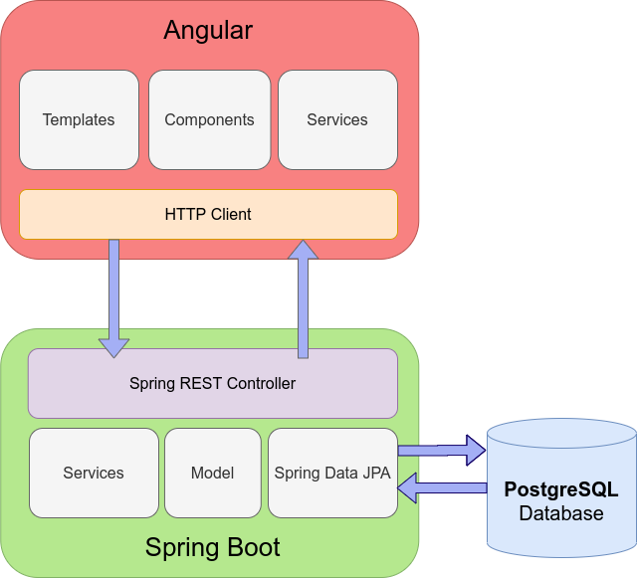

The system architecture depicted in the diagram below illustrates the flow of requests from users to databases through servers. The overall system is organized into three levels, utilizing three layers: the presentation layer, business layer, and data link layer. This project was developed using a three-tiered design approach.

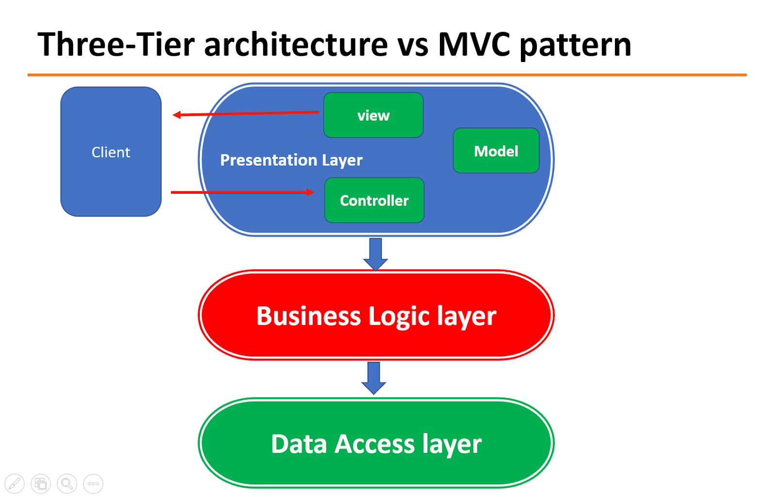

**Tier Architecture:**

In response to the limitations of the two-tier design, the three-tier software architecture, also known as the three-layer architecture, emerged during the 1990s. Positioned between the user interface (client) and the data management (server) components is the third tier, or middle tier server. This middle tier serves as the hub for process management, implementing business logic and rules, and can support a larger number of users compared to the two-tier design. It provides functions such as queuing, application execution, and database staging.

Compared to the two-tier architecture, the three-tier architecture offers several advantages including improved speed, flexibility, maintainability, reusability, and scalability. Additionally, it shields users from the complexity of distributed operations. These benefits have made three-layer architectures a popular choice for Internet applications and net-centric information systems.

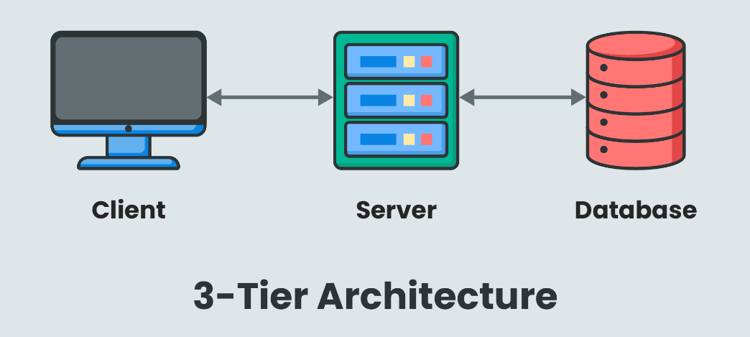

**Software Requirement Specification:**

A software requirement specification (SRS) is a comprehensive document that lists all a software system's functional and non-functional needs. Several use examples are frequently included to show how users interact with the product. Providing a precise and unambiguous explanation of the expected and non-expected functions of the software is the primary goal of an SRS. An SRS provides the foundation for stakeholder consensus regarding the software product's specifications by creating a shared understanding.

By specifying criteria prior to the start of the design phase, an SRS helps ensure a complete review process and helps avoid the need for revision later. In the end, it's an essential document in the software development process that makes sure the system satisfies stakeholders' requirements and expectations.

**Software Requirements:**

* A Computer with a supported Operating system.
  + macOS 10.12 or higher
  + Windows 7 or higher
  + Linux (x64)
* Node JS
* JDK
* MySQL Workbench.
* Integrated Development Environment
  + Visual Studio Code
  + Eclipse / Spring Tool Suite

**Hardware Requirements:**

* A computer with a supported processor:
  + Intel Core i5 or higher
  + AMD Ryzen 5 or higher
* A computer with a supported graphics card:
  + Intel HD (Huntington Disease) Graphics 520 or higher
  + AMD Radeon R7 260 or higher
* A computer with at least 4GB of RAM (Random Access Memory).
* A computer with at least 2GB of free disk space
* Monitor:
  + A monitor with a resolution of at least 1920x1080 pixels
  + A monitor with a refresh rate of at least 60 Hz
* Keyboard:
  + A keyboard with a standard QWERTY layout
  + A keyboard with a number pad

**METHODOLOGY:**

Med Patient Portal Web Application is typically designed with various features to handle various departments like Administrative, Clinical, Medical, Laboratory, and Operational Processes.

* **Patient:**

1. The patient can be able to register to the portal.

2. He/She can be able to log in with the username provided in the

Email.

3. After Login they can Edit the Patient profile

4. View / Search Doctors.

5. View / Book Appointment based on Selected Doctor.

6. Pharmacy management of adding medicines to the cart and ordering online.

7. Bill Payment.

* **Doctor:**

1. With the help of the Management portal, doctors can be able to log in and access the portal.
2. Add the timetable of the week.
3. Edit Profile
4. Change Password
5. View Patients
6. View Emergency Contacts of Patients
7. Respond to the appointment of the patient.
8. Suggest medication to the appointment request.

**Data Flow Design Diagram**

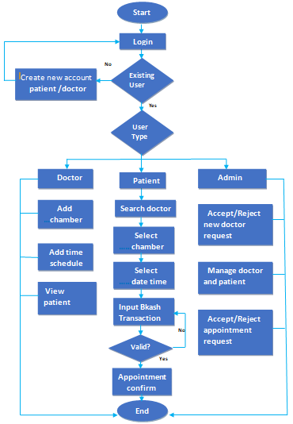

**UML Diagram:**

A UML diagram, or Unified Modeling Language diagram, is a visual representation of a system or process using standardized symbols and notation. UML diagrams are widely used in software engineering and other fields to design, document, and communicate about systems and their components.

Class Diagram: Represents the static structure of a system by showing classes, their attributes, methods, and relationships.

**ER Diagram:**

An Entity-Relationship (ER) diagram is a visual representation of the relationships between different entities within a system or database. It depicts how these entities are related to each other through various types of relationships such as one-to-one, one-to-many, or many-to-many.

In an ER diagram, entities are represented as rectangles, and relationships between entities are depicted using lines connecting them. Each entity has attributes associated with it, which are shown within the rectangle representing the entity.

The primary purpose of an ER diagram is to provide a clear and concise overview of the data model, illustrating the structure of the database and the relationships between its various components. It helps in understanding the organization of data and assists in database design and implementation.

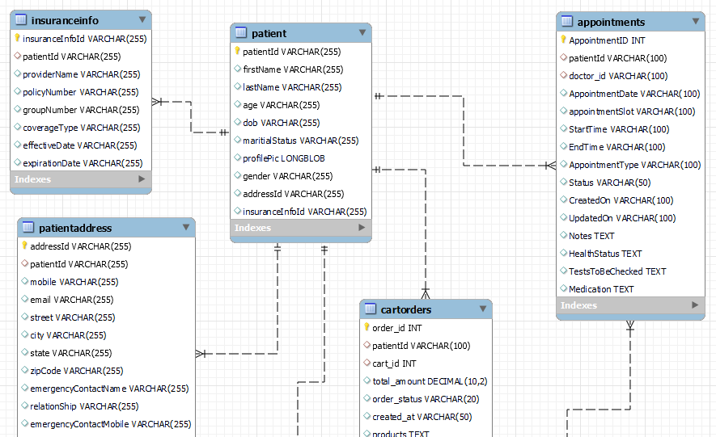

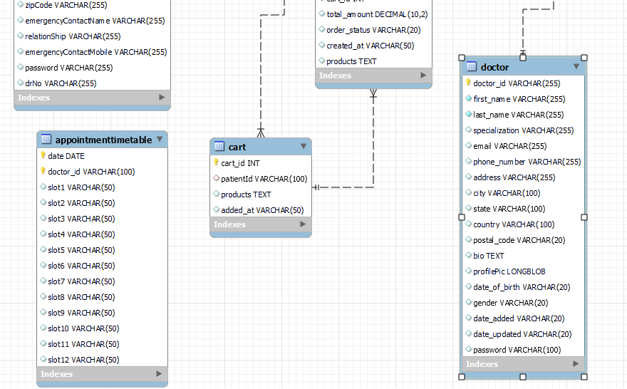

**Project Life Cycle:**

The project life cycle refers to the series of phases that a project goes through from initiation to completion. While specific methodologies and terminology may vary, the project life cycle typically consists of the following stages:

* **Initiation:** During this stage, the project is specified and conceptualized. It includes figuring out why the project is necessary, outlining its goals, and assessing its viability. Performing a feasibility study, establishing the project's parameters, and obtaining preliminary funding and approvals are a few examples of important tasks.
* **Planning:** The planning stage starts as soon as the project is launched. Detailed plans are created at this stage to direct the project's implementation. This comprises specifying the tasks involved in the project, calculating the number of resources needed, generating timelines, allocating funds, and developing procedures for risk and quality control. The project schedule functions as
* **Execution:** The project work is carried out by the project plan during this phase. Project teams carry out the tasks listed in the plan, manage resources, report on developments, and deal with any problems or adjustments that come up. To make sure the project stays on course and achieves its goals, this phase frequently entails routine monitoring and regulating.
* **Monitoring and Controlling:** Activities related to tracking progress, spotting deviations from the plan, and taking necessary corrective action are carried out at various stages of the project life cycle. This entails managing changes, assessing potential risks or issues, comparing actual performance to projected performance, and evaluating project data.
* **Closure:** The project life cycle concludes the closure phase. At this point, the project is formally closed out and its deliverables are finalized. Getting final clearances, transferring deliverables to stakeholders or end users, performing post-mortems or project reviews, and archiving project documentation are a few examples of activities. Project closure guarantees that goals are met, resources are relinquished, and lessons learned are recorded for use in subsequent initiatives.

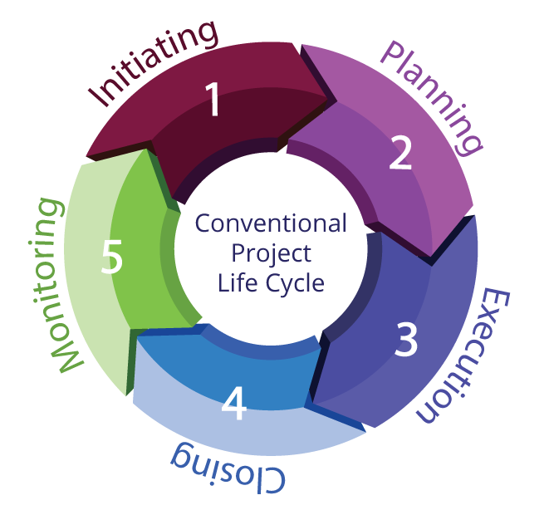

* These stages serve as a broad framework for project management, but the actions and tasks that fall under each category might change based on the project's complexity and nature as well as the project management approach that is selected. Effective planning, execution, and successful project delivery can be achieved by businesses through adherence to a defined project life cycle.

**Service Start-Up:**

1. **Front End Angular Application:**

* To start the service, go to the project folder and we can open it in integrated terminal and trigger node module or angular startup

ng serve

npm start

Once started the service is running in localhost server with port number 4200

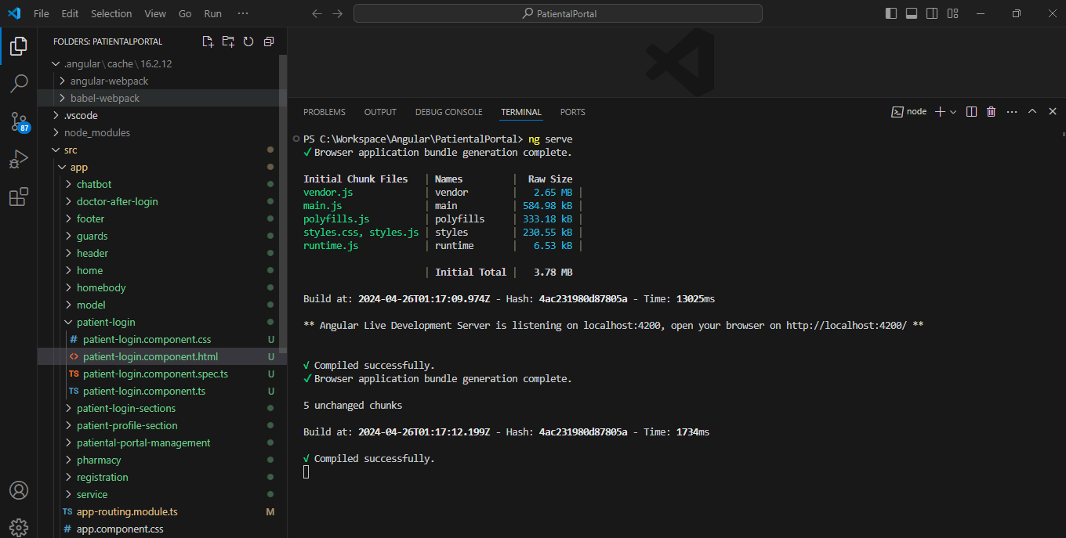

1. **Backend Java Spring boot Application**

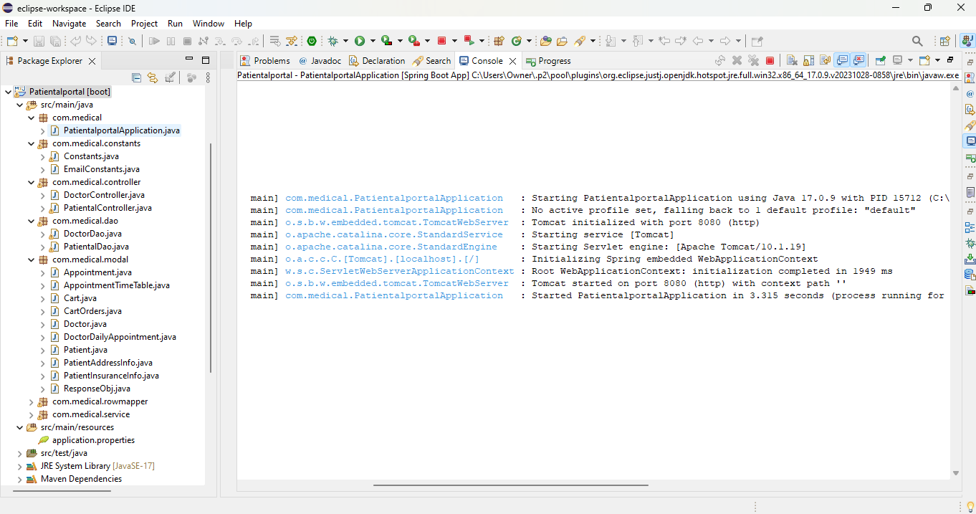

**Screenshots Of Designed Web Application:**

1.Med Portal Home Page

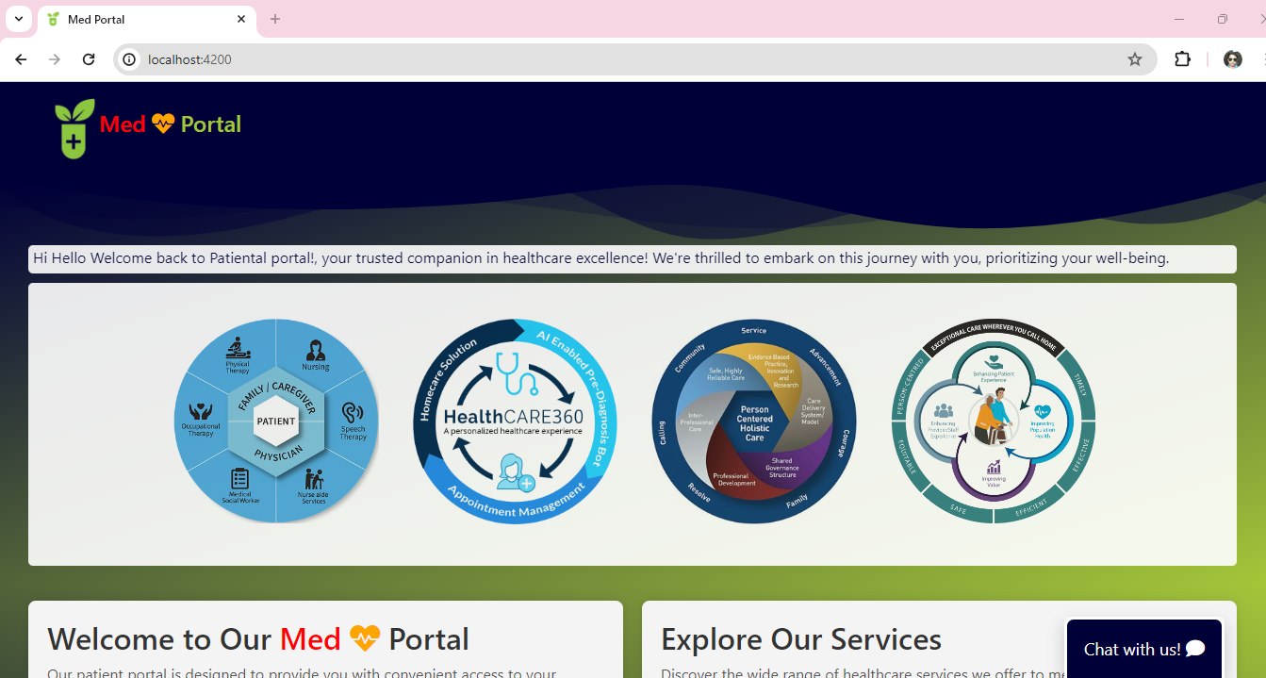

**Patient Can able to register and login**

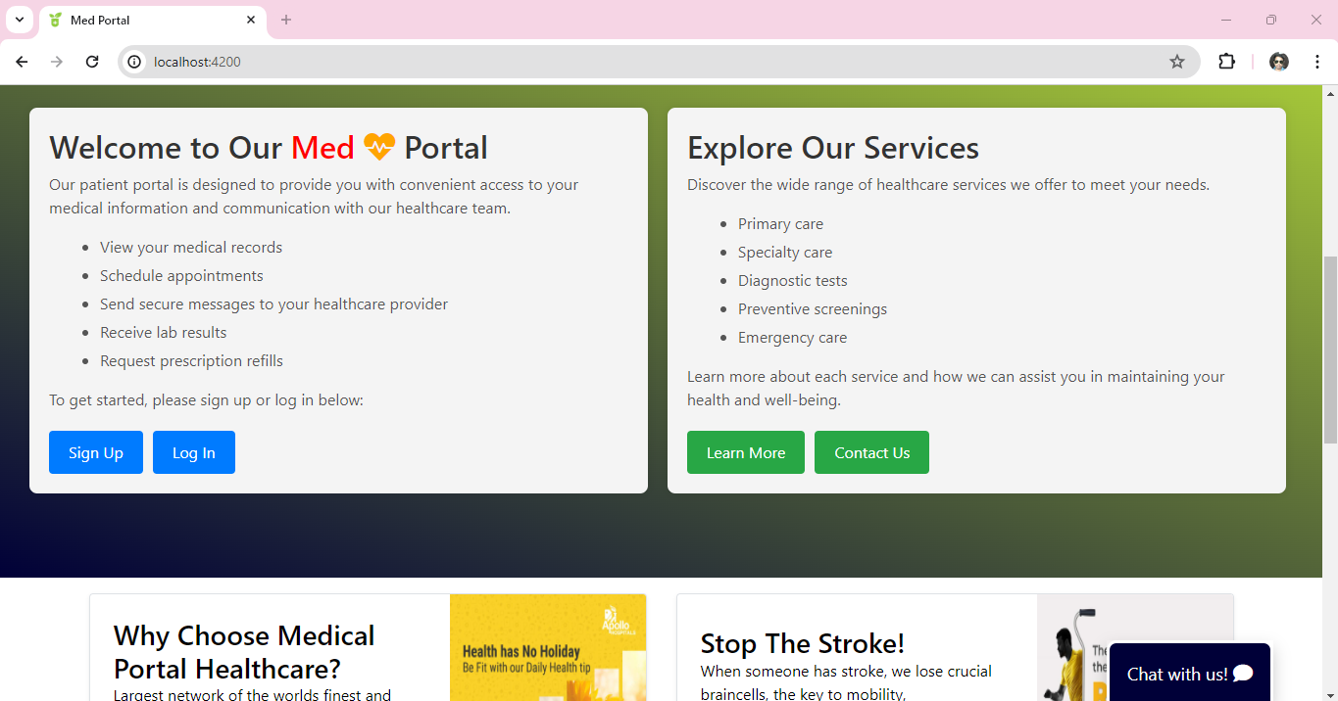

**Element designed to showcase some important features and services**

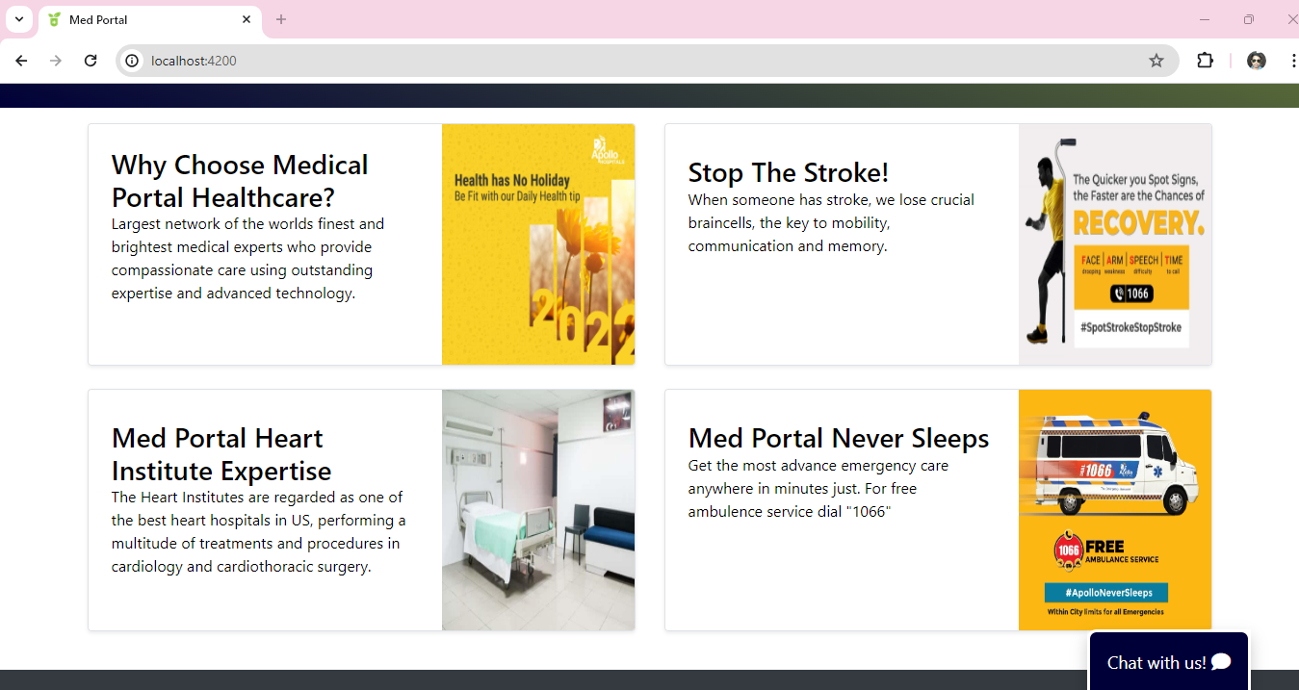

**Footer Section is designed to provide contact information of the portal**

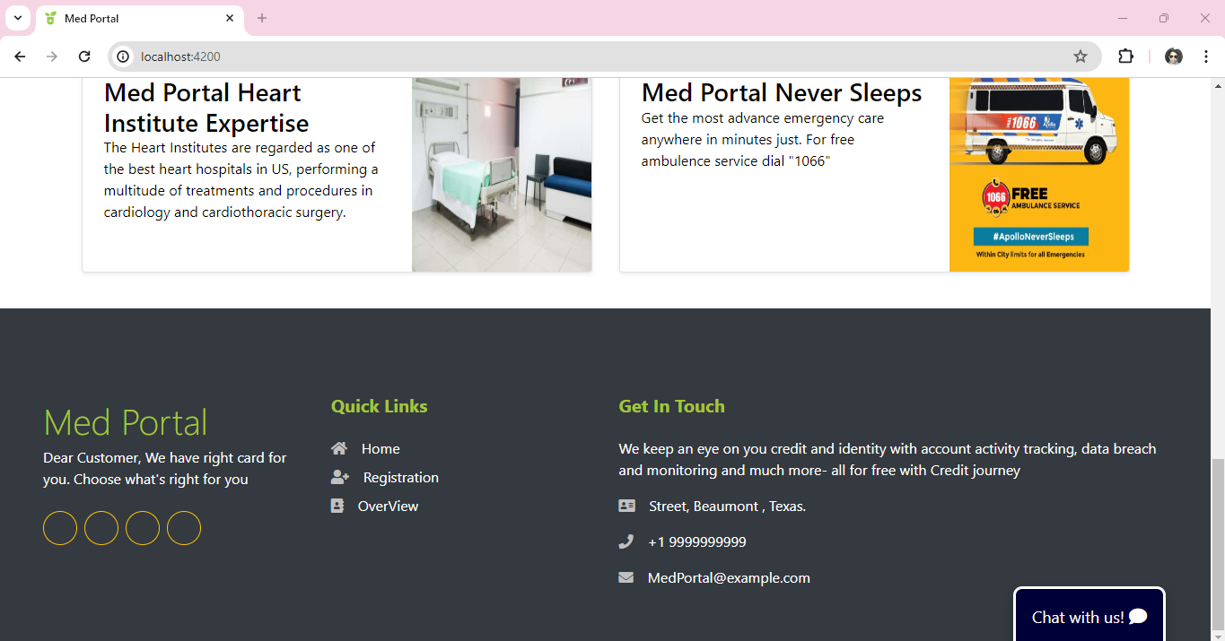

2.ChatBot to respond to the instant messages.

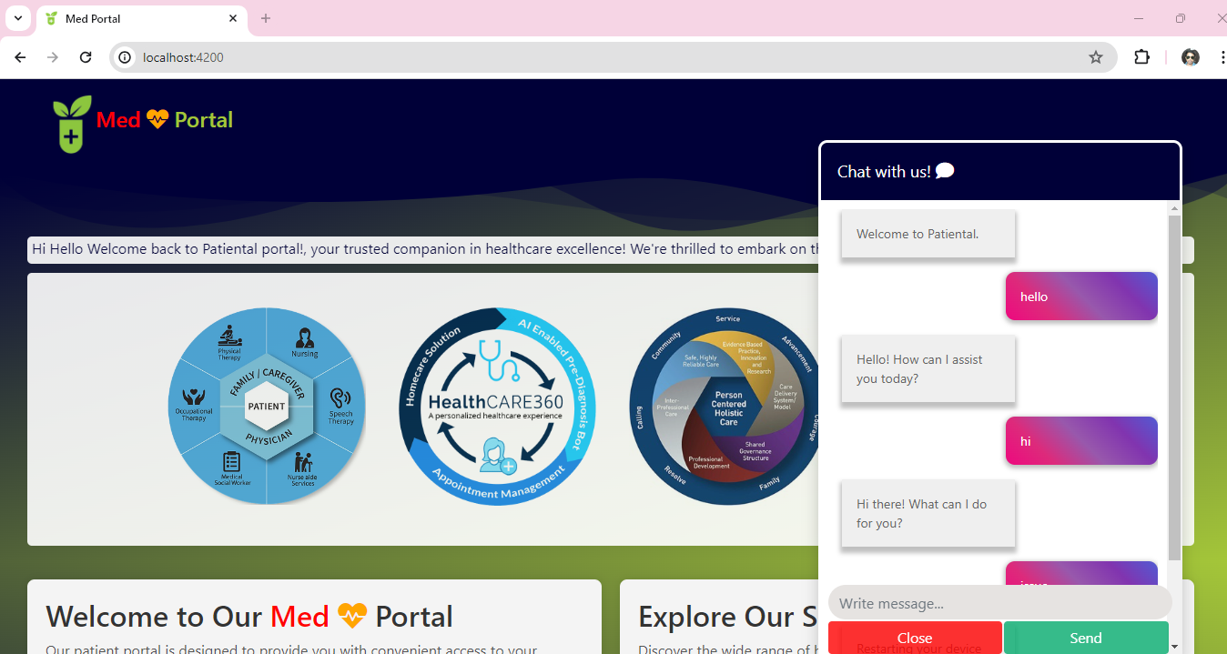

3.Management Portal for Doctors and hospital employees and other usage

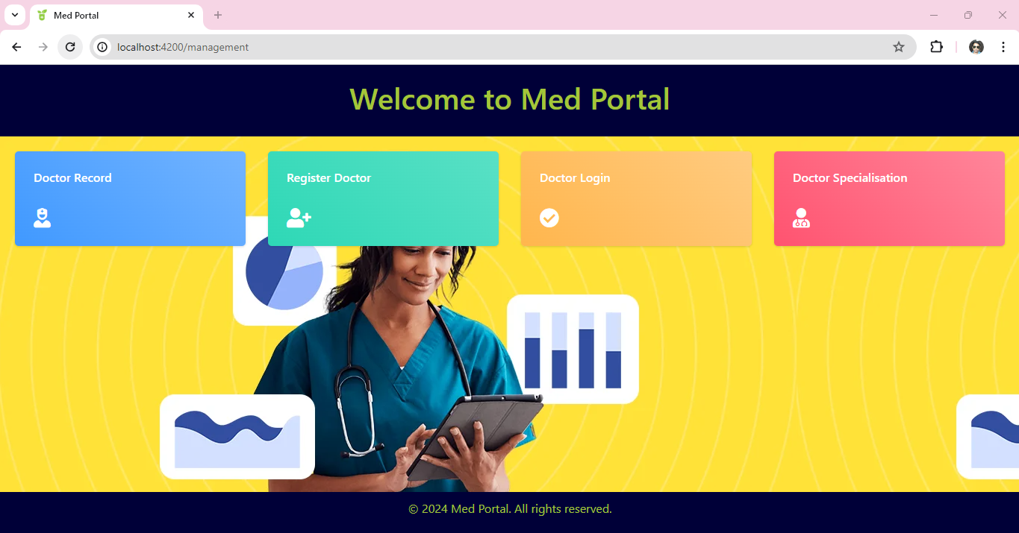

As Of now, there is only a Doctor Login. Other flows were created for future reference.

4. Patient Registration: designed with field validations as requirement

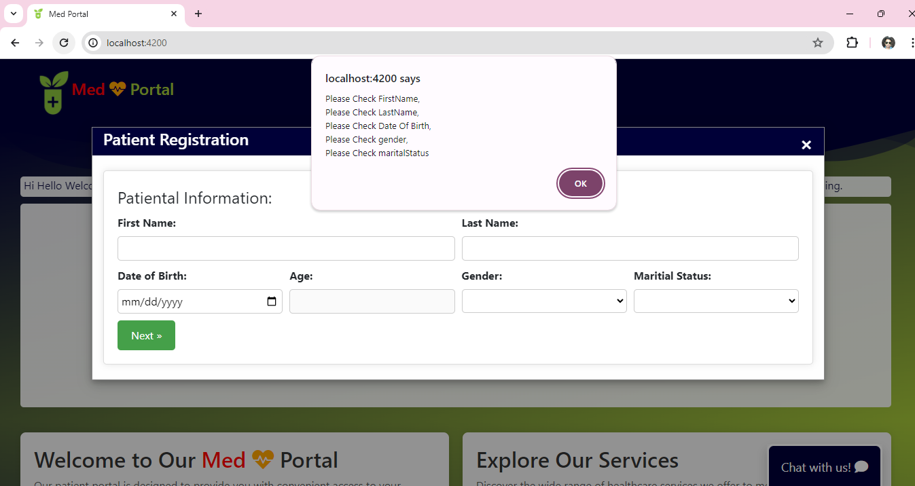

If the user misses filling any required field, it will throw in popup to the user notice.

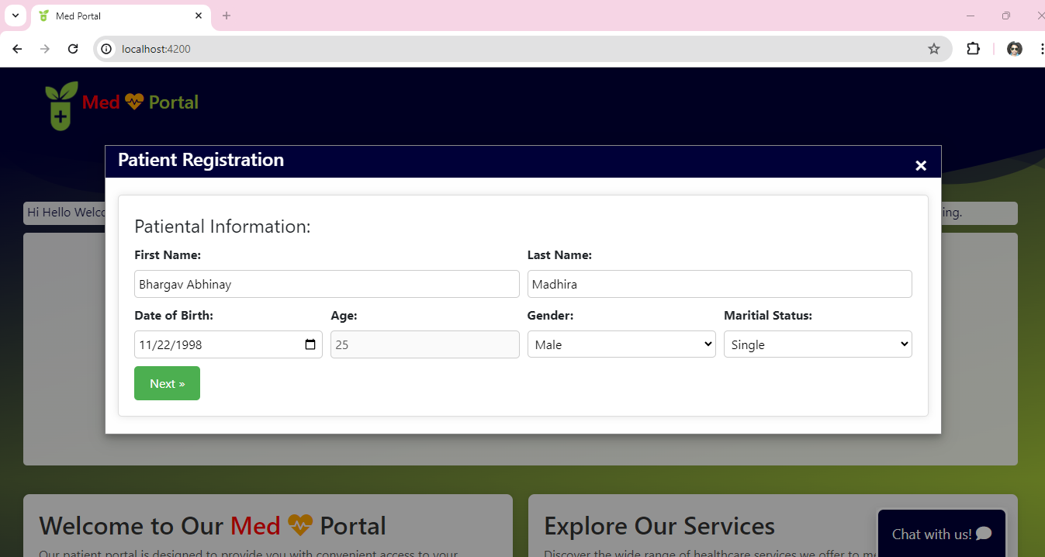

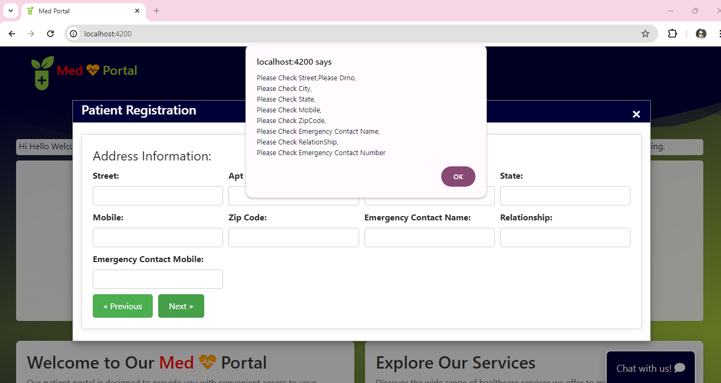

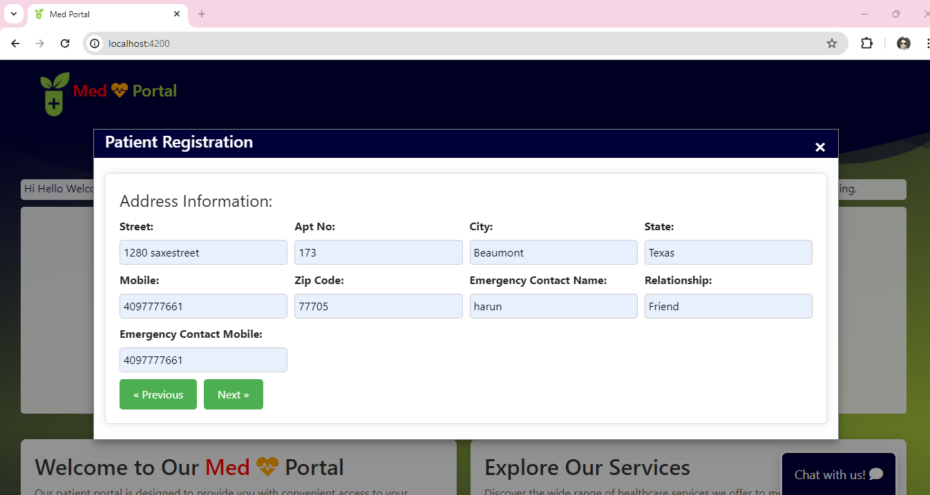

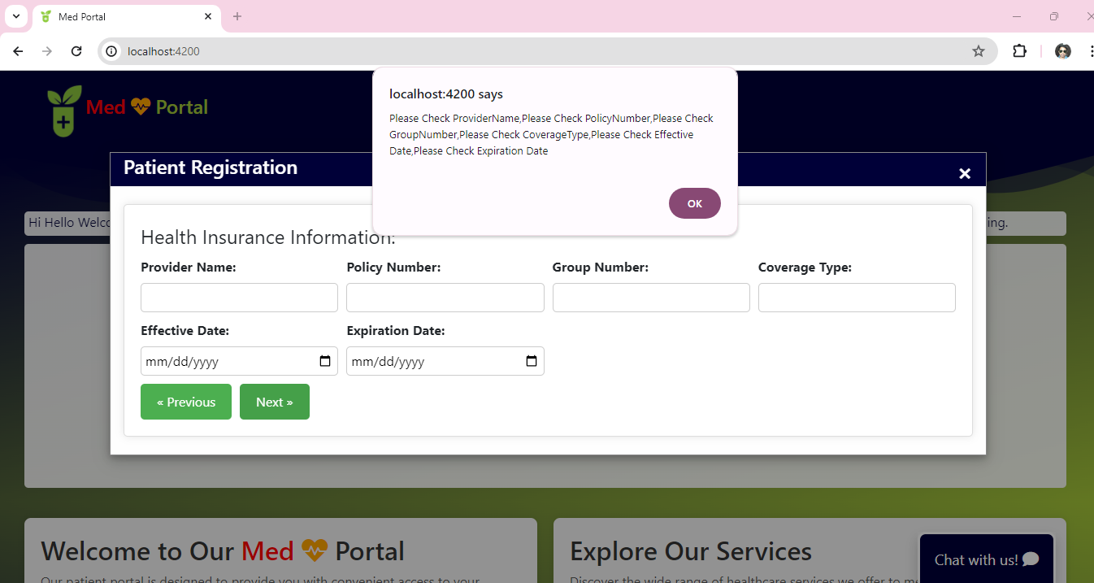

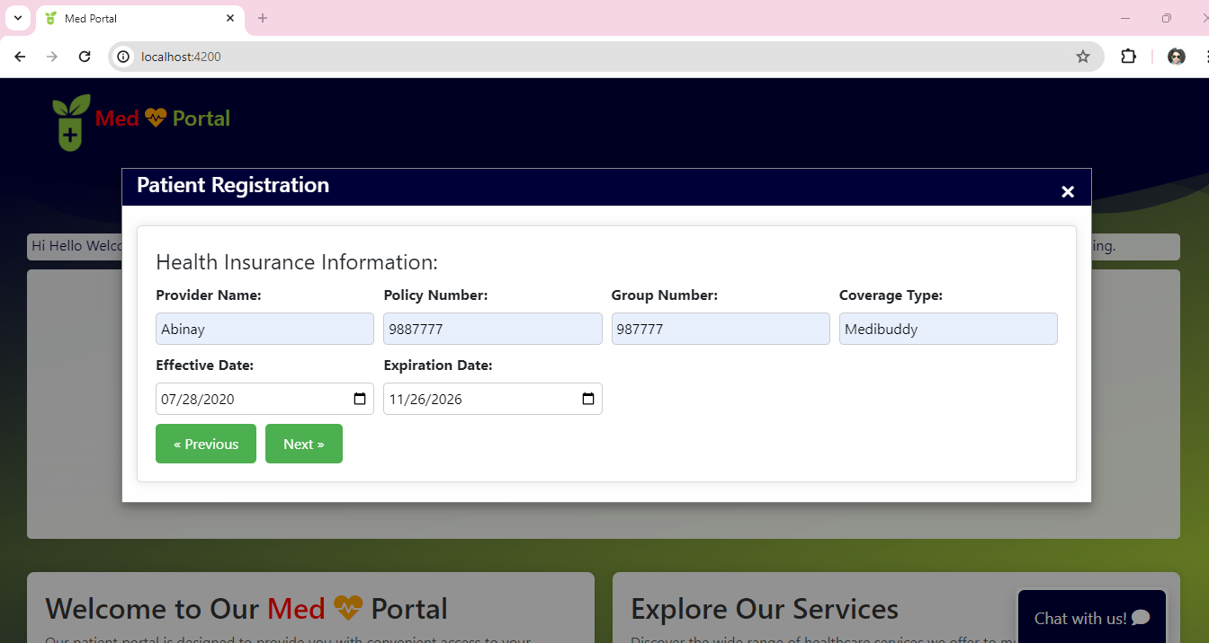

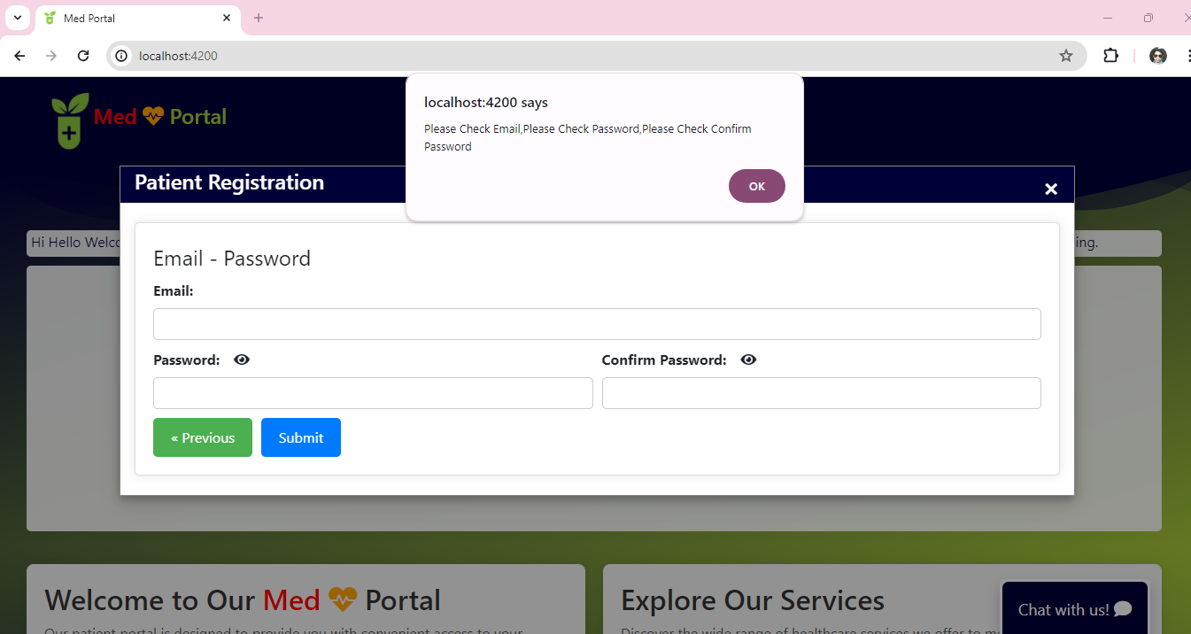

We can able to view password and if password is not in the required pattern it will throw instant error message

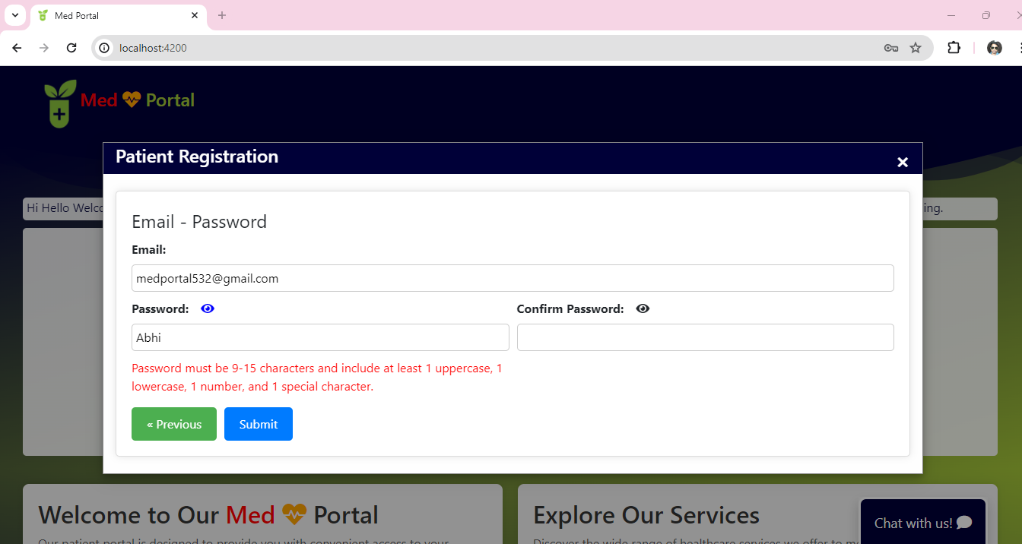

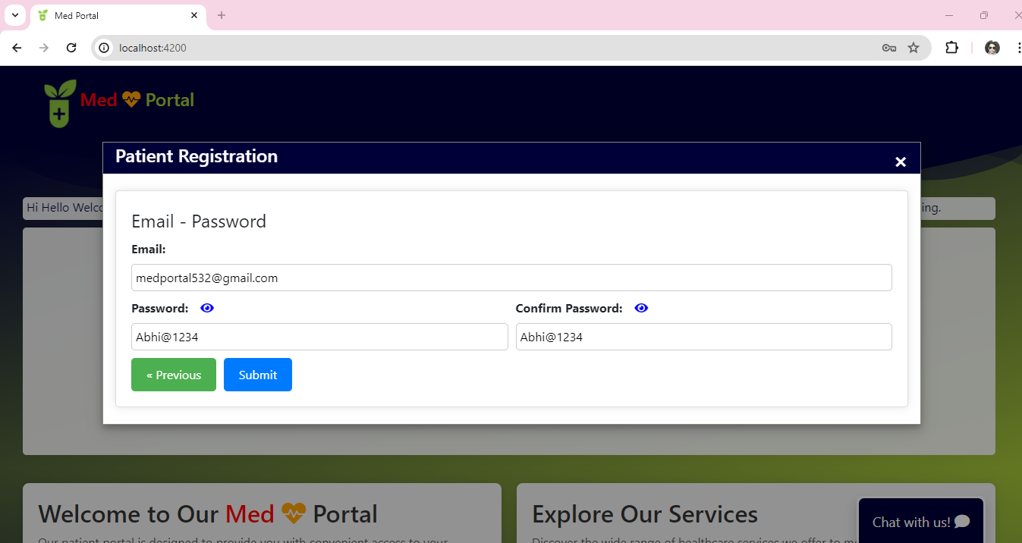

Patient Registration Success.

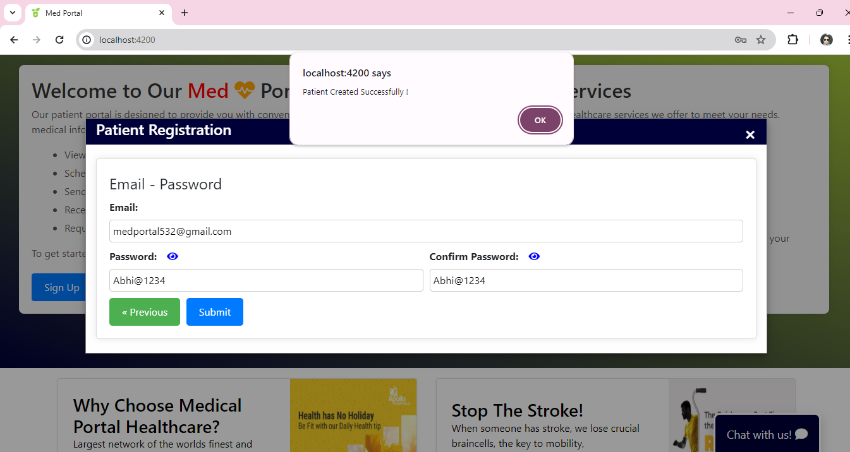

If Patient Already Exists, it will trigger Already Exists

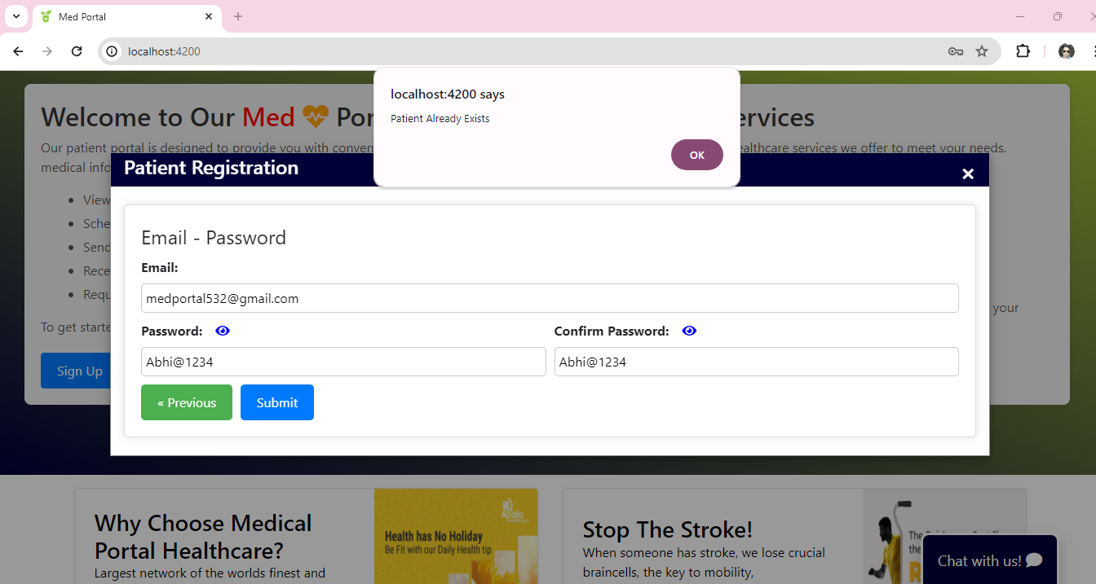

Patient Created Successfully

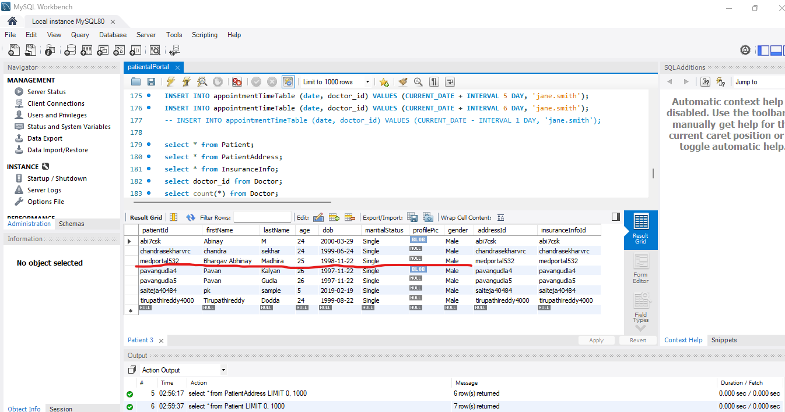

Gmail notification regarding registration Success and also gives info related to username

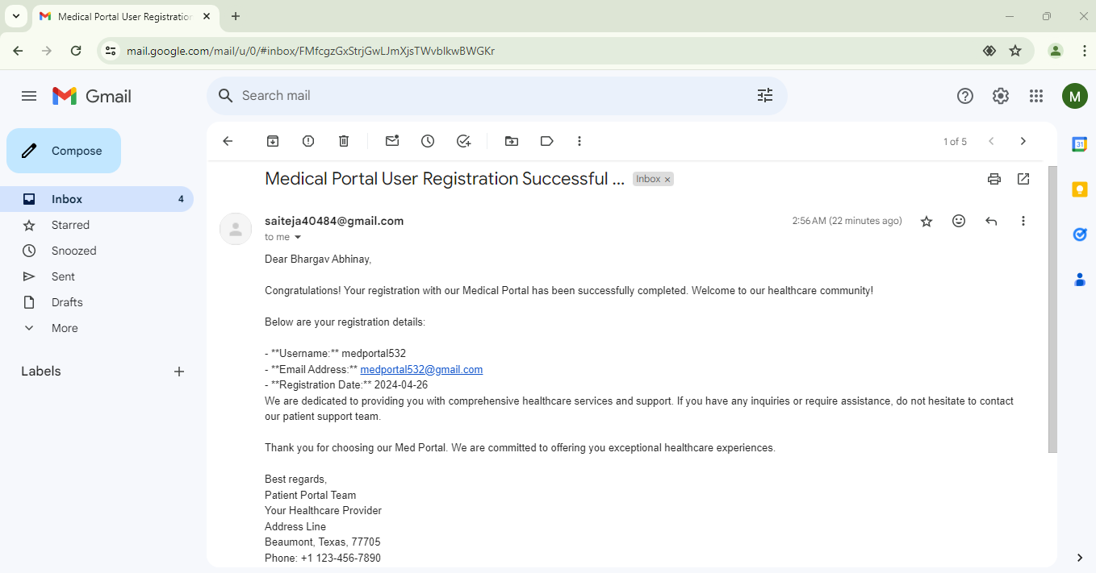

5. Patient Login

If the user not registered. It will show Not Found.

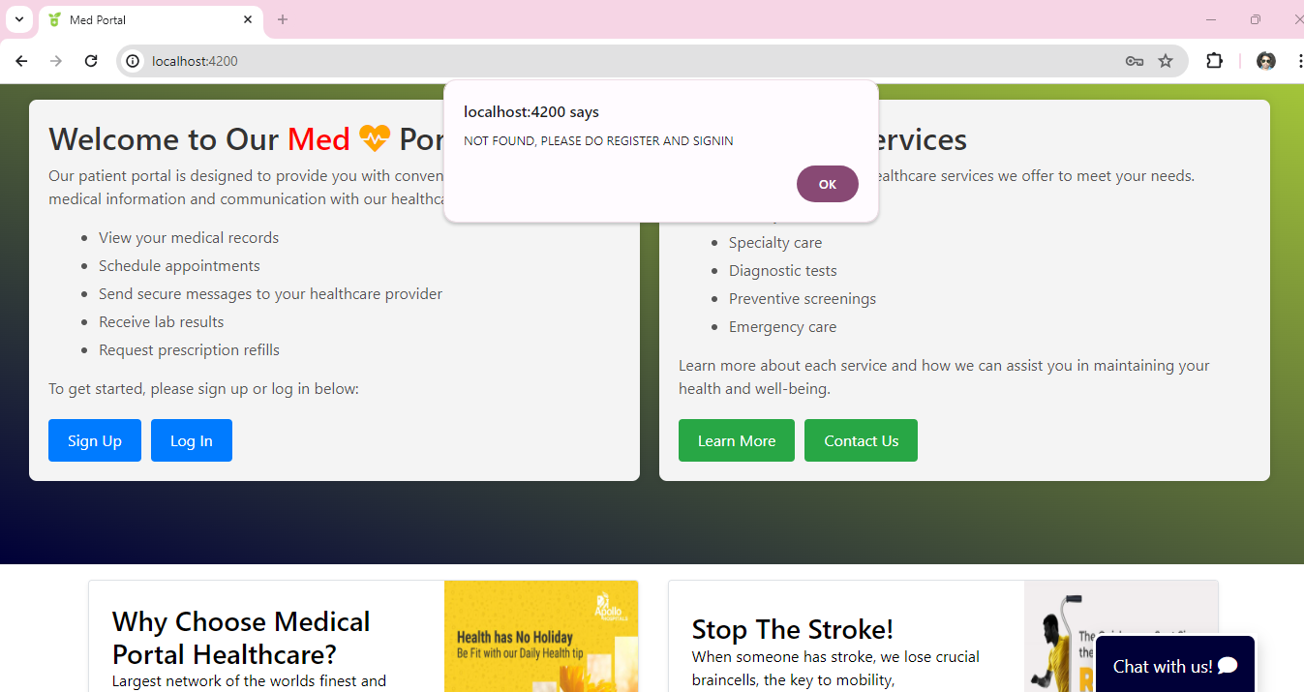

Incorrect Password scenario

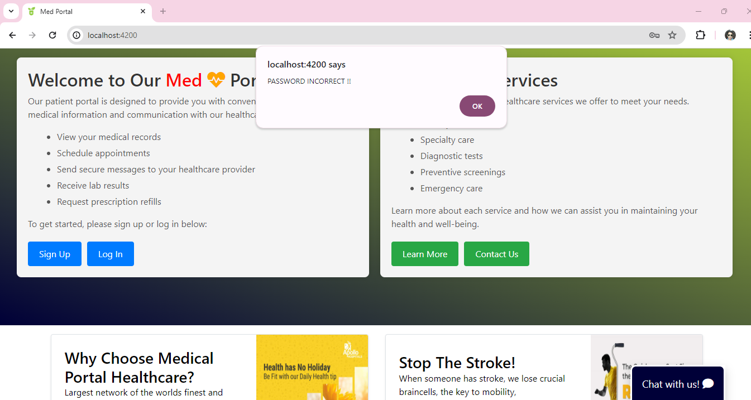

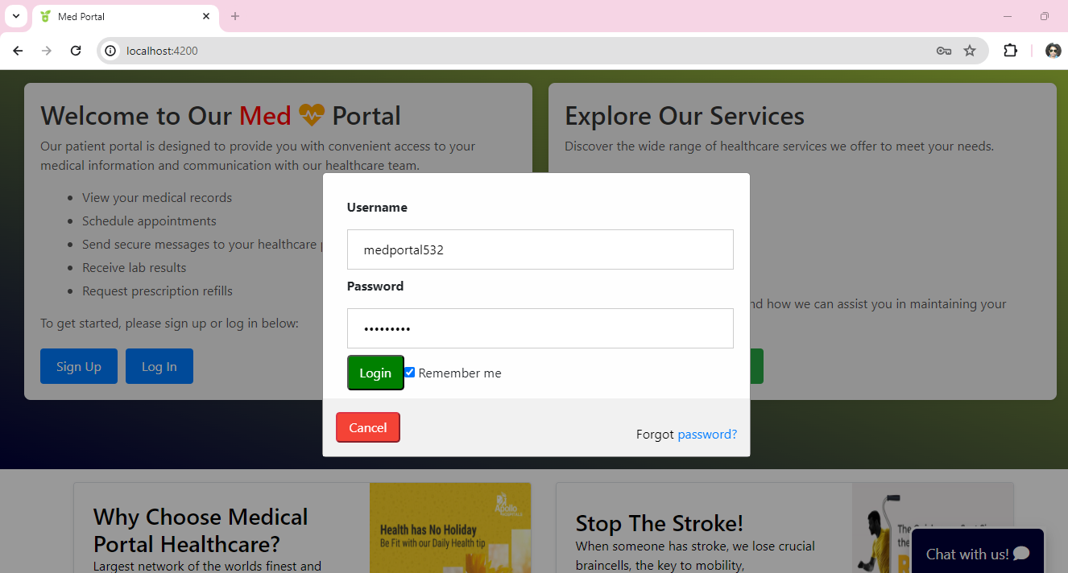

* Once the Provided Username and Password are Valid. It successfully logged in to the patientAfterLogin Page.

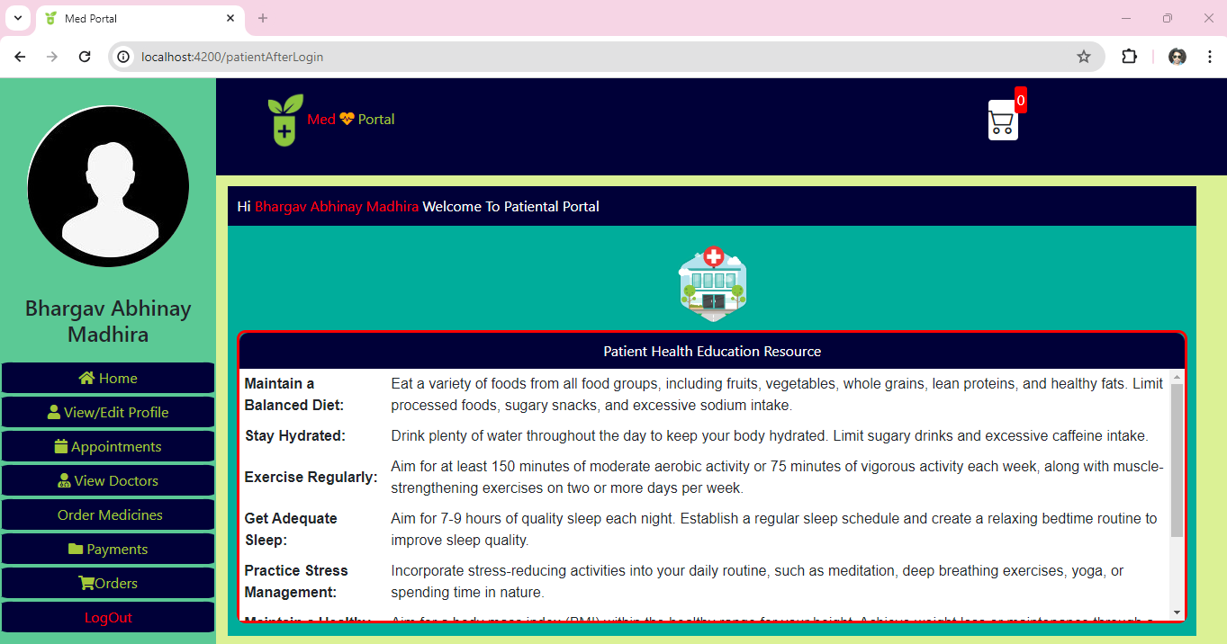

* Patients can be able to view or edit profile information as expected.

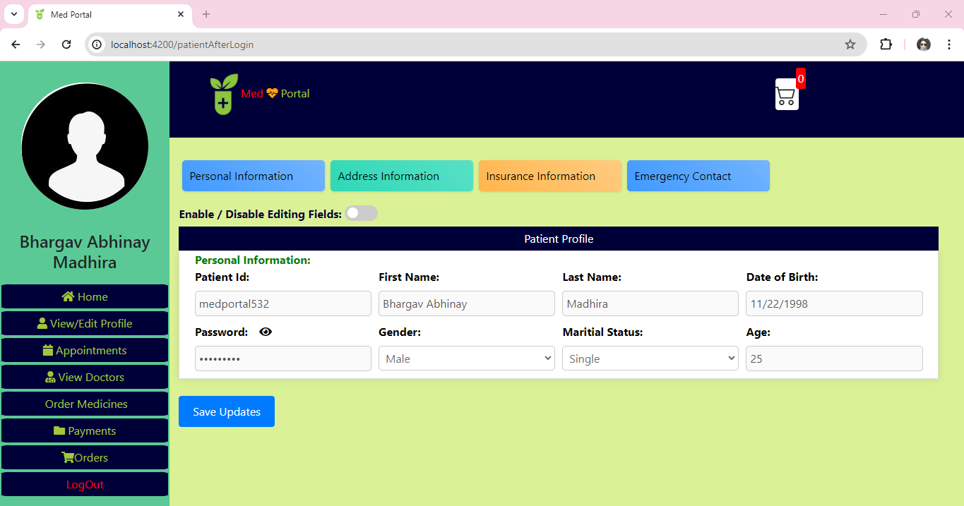

* Patients can be able to change their profile Pic.

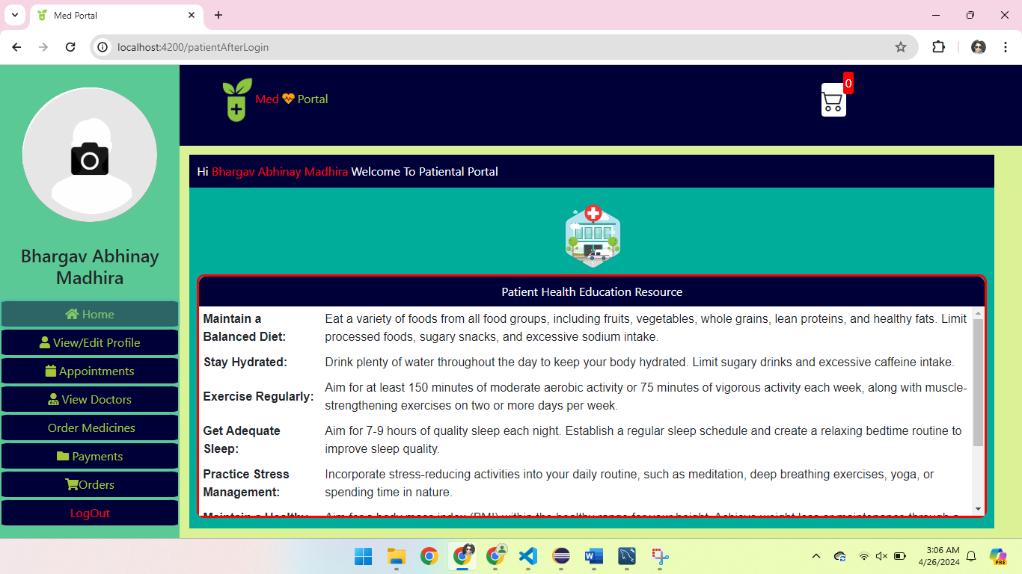

* Confirmation of changing User Profile pic. If click Ok it will be changed or else ignored in last minute.

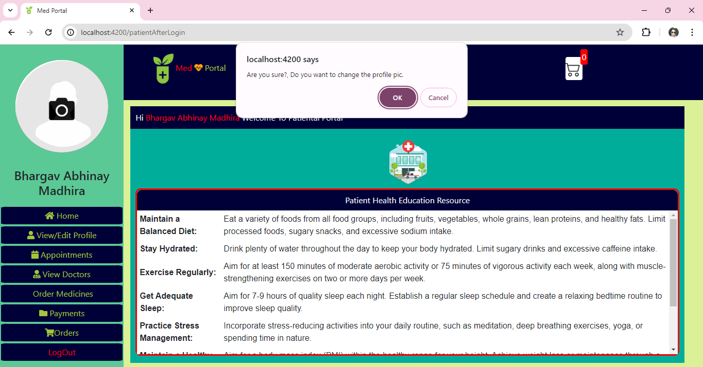

* Successfully Profile pic updated into Database.

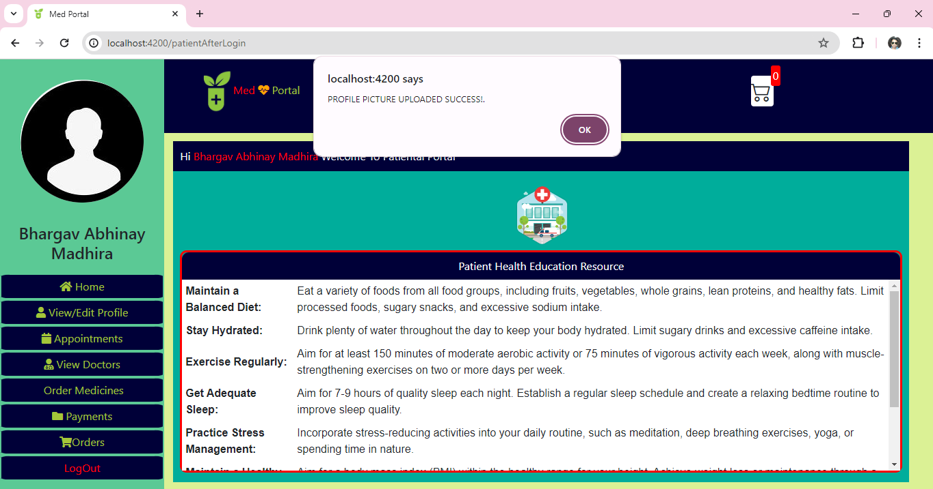

* Once after profile pic is updated immediately it will be retrieved and populated on the screen.

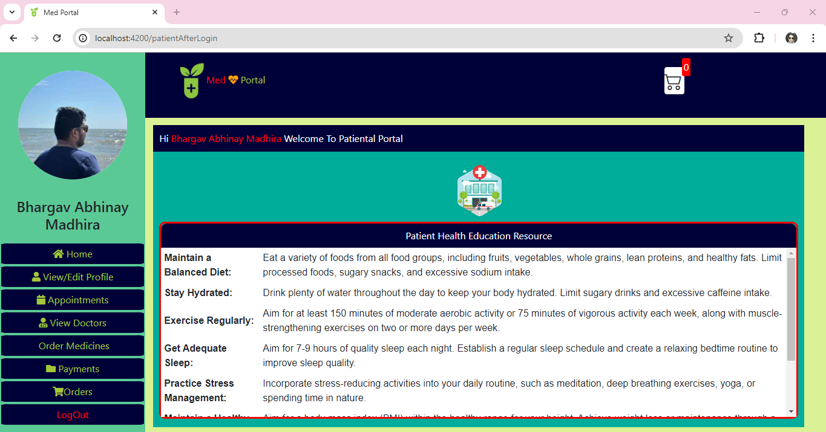

* In the appointment screen, we can track upcoming appointments.
* Able to view available appointments of selected Doctors based on dates and slots available.

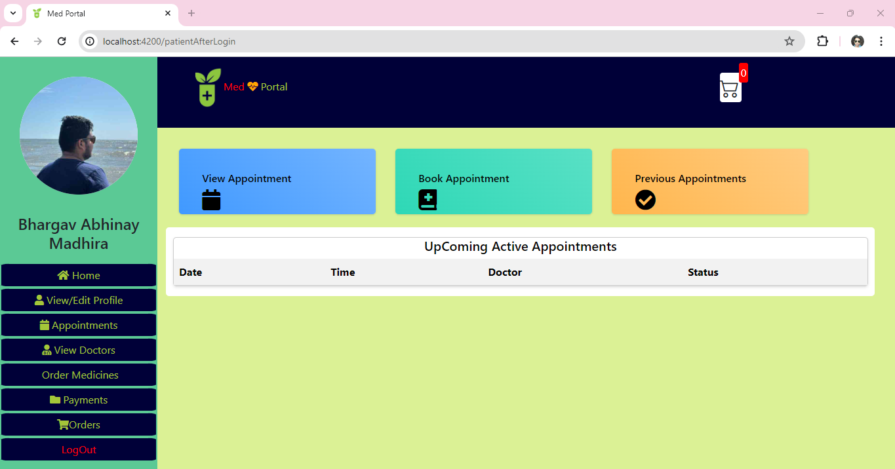

* Selected Doctor in the dropdown list pulls and populates doctor appointments in the table

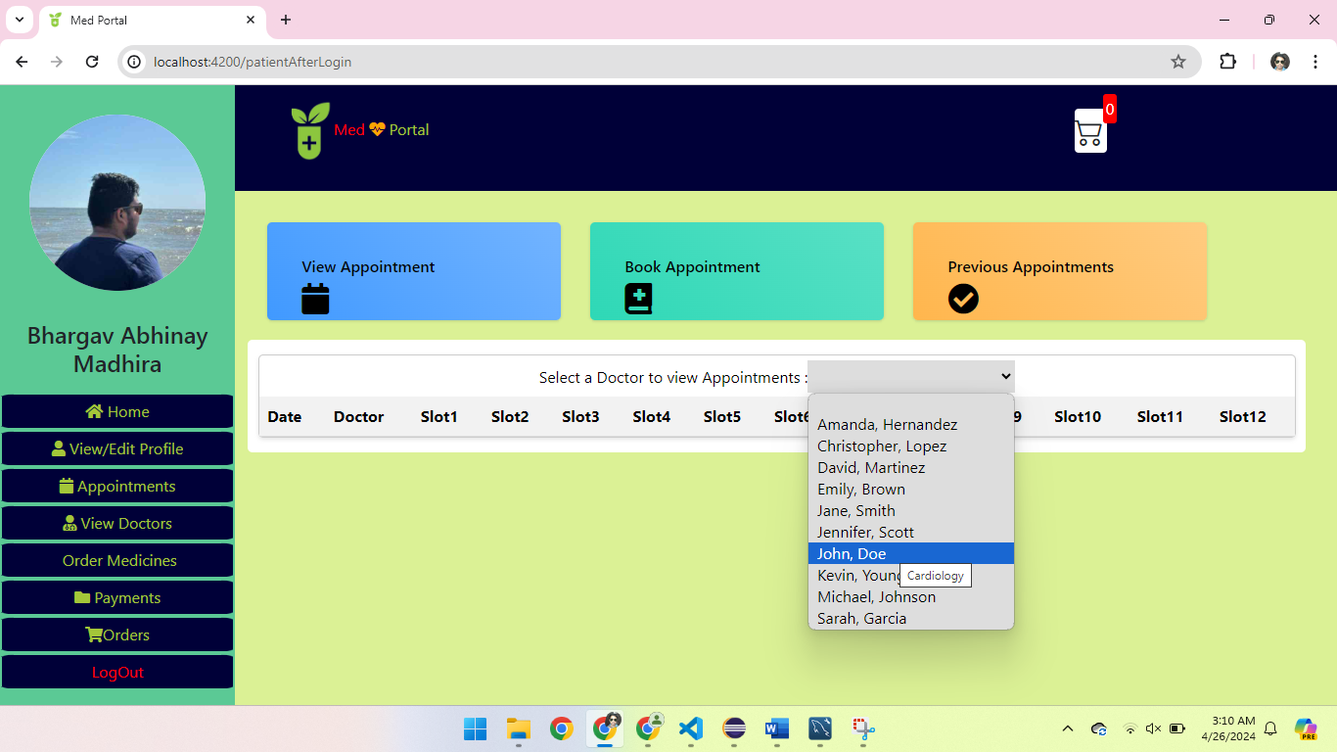

* Available slots will be displayed as below.
* Appointment booked slots will be displayed in green color checkbox.

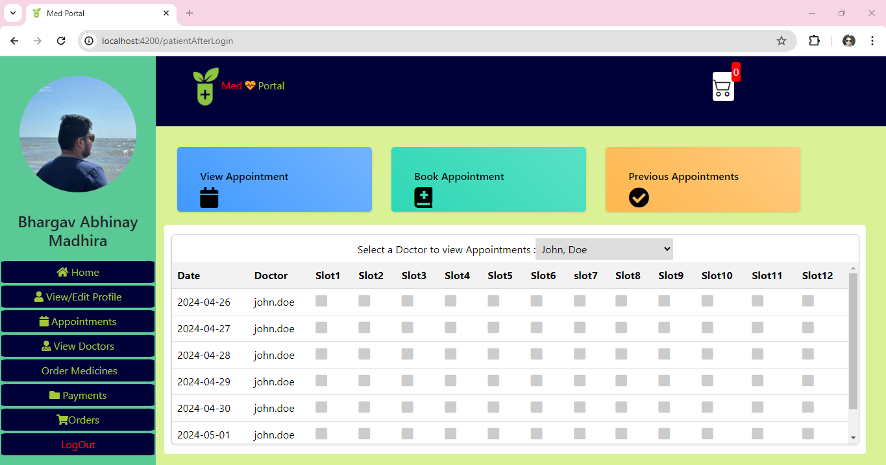

Booking Appointment

* Select doctor and dates available.
* Based on selected dates. It will give available slots of the doctor on that date.

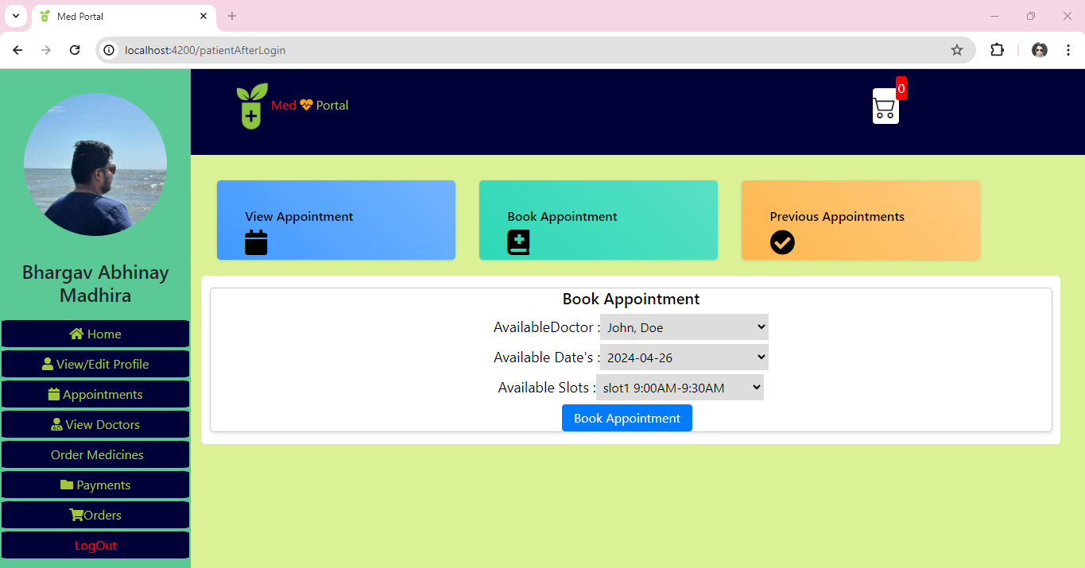

* Once appointment scheduled it will show Success.

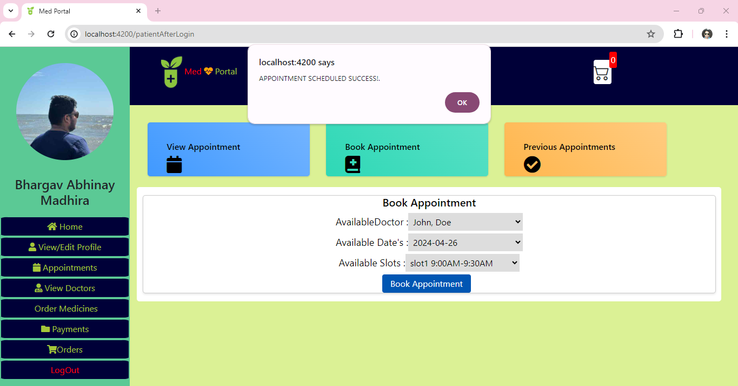

* That slot will be blocked, and wont shown again for others.

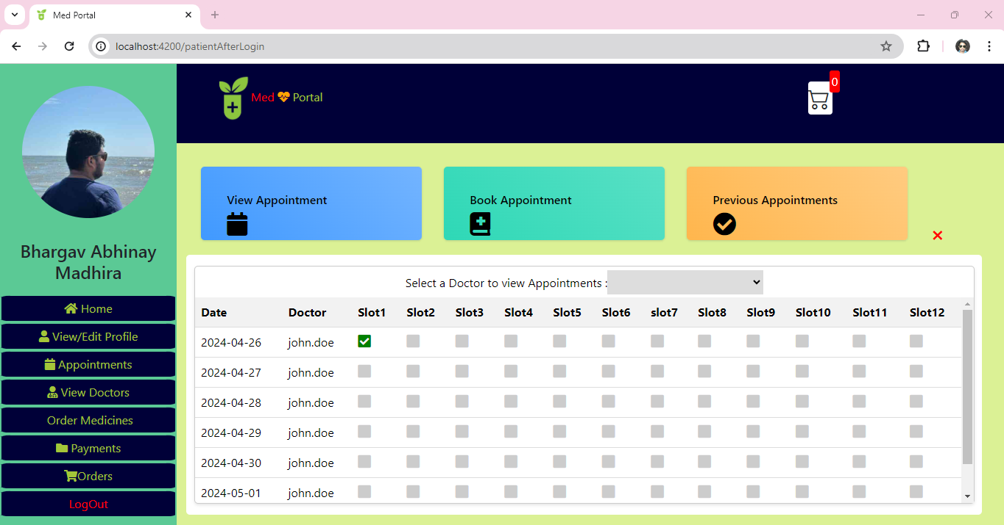

* You can view the upcoming appointments of logged-in patient.
* Previous appointments section shows previous appointments of patient.

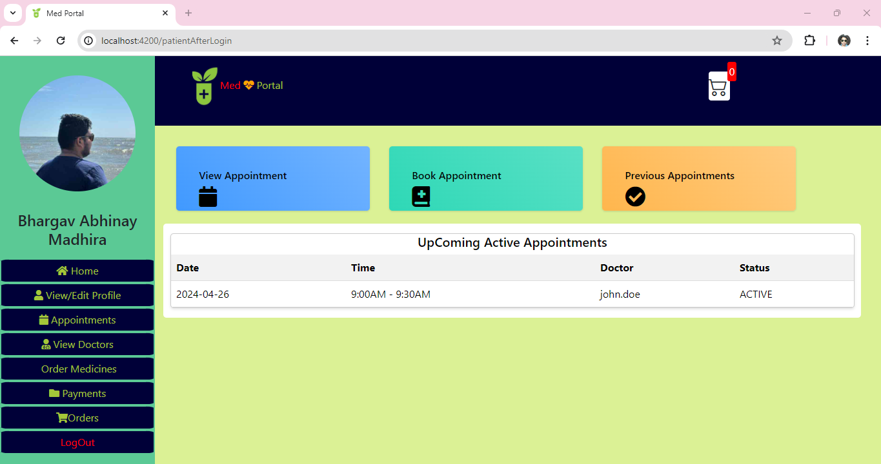

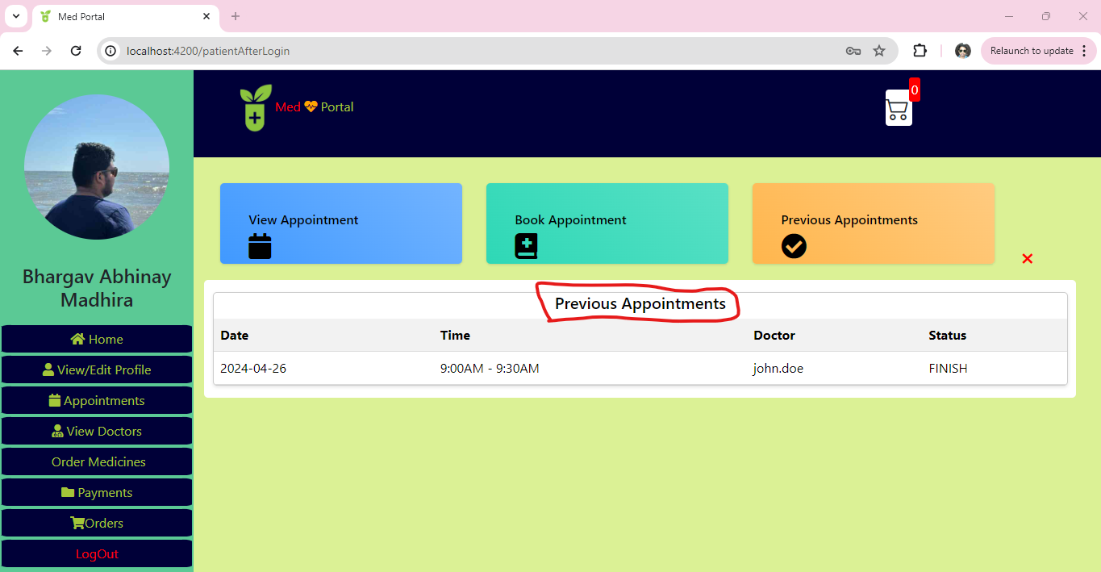

* We can open and view the medication of previous appointments

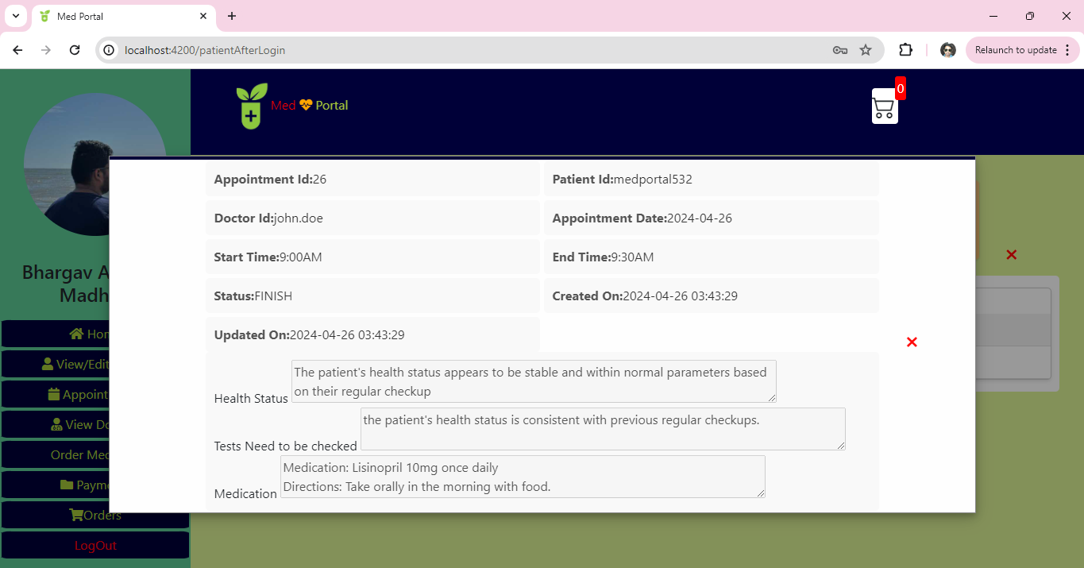

* Search Doctors based on any field values in the table

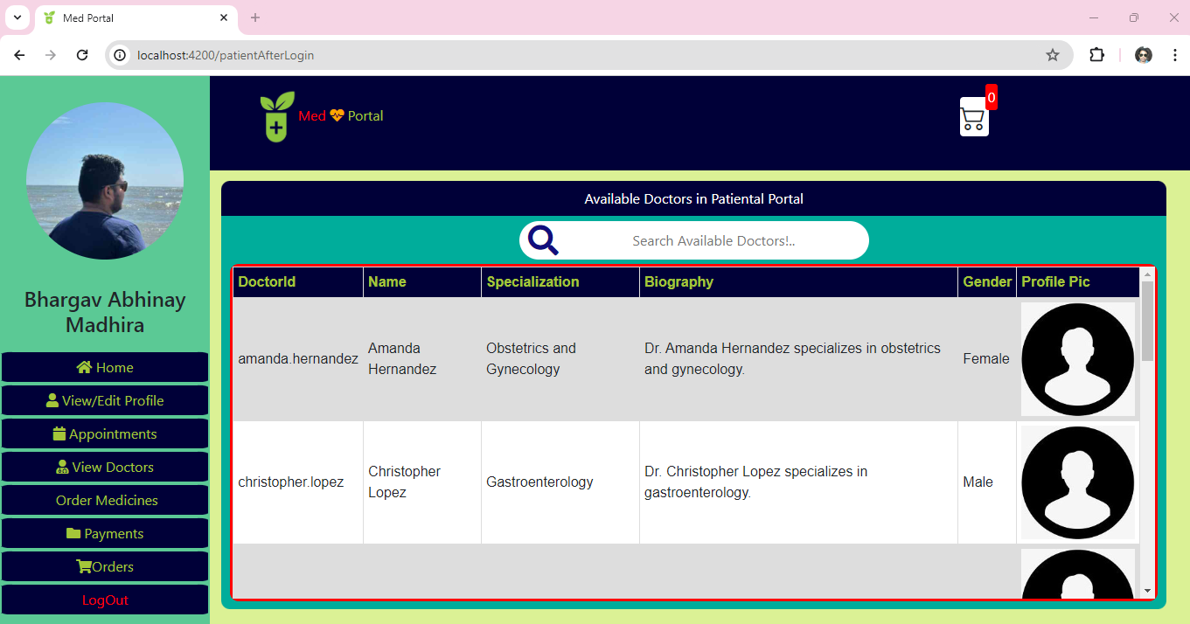

* Search the products provided below

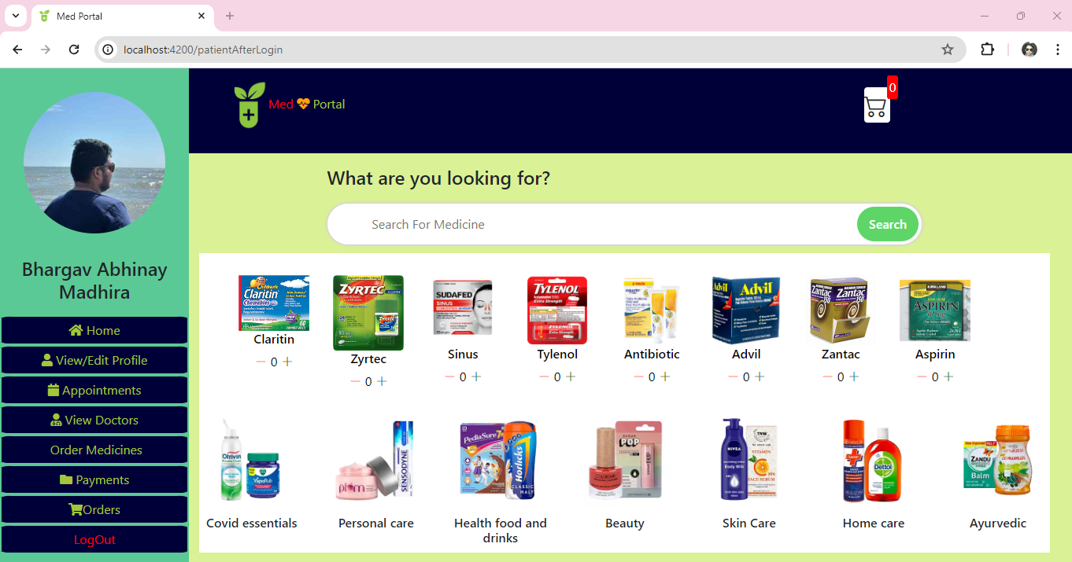

* Add the products to cart

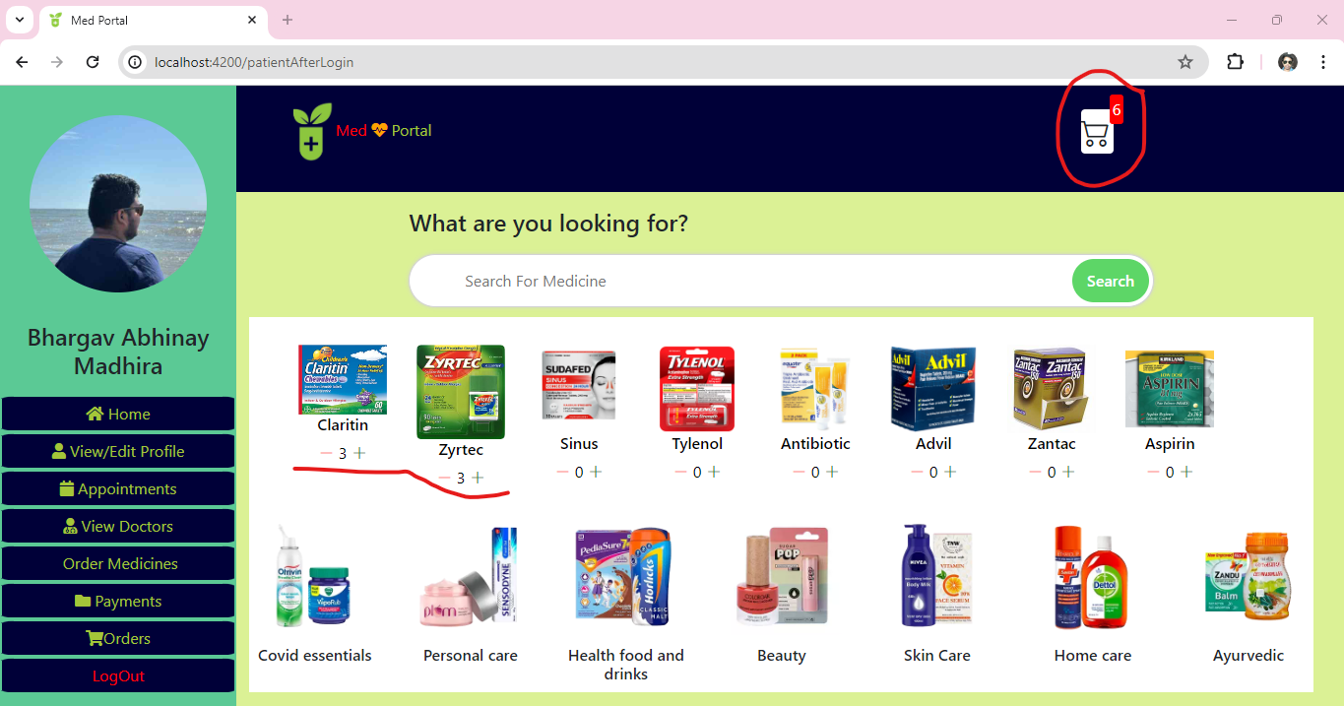

* Open cart and view the items in cart and the invoice

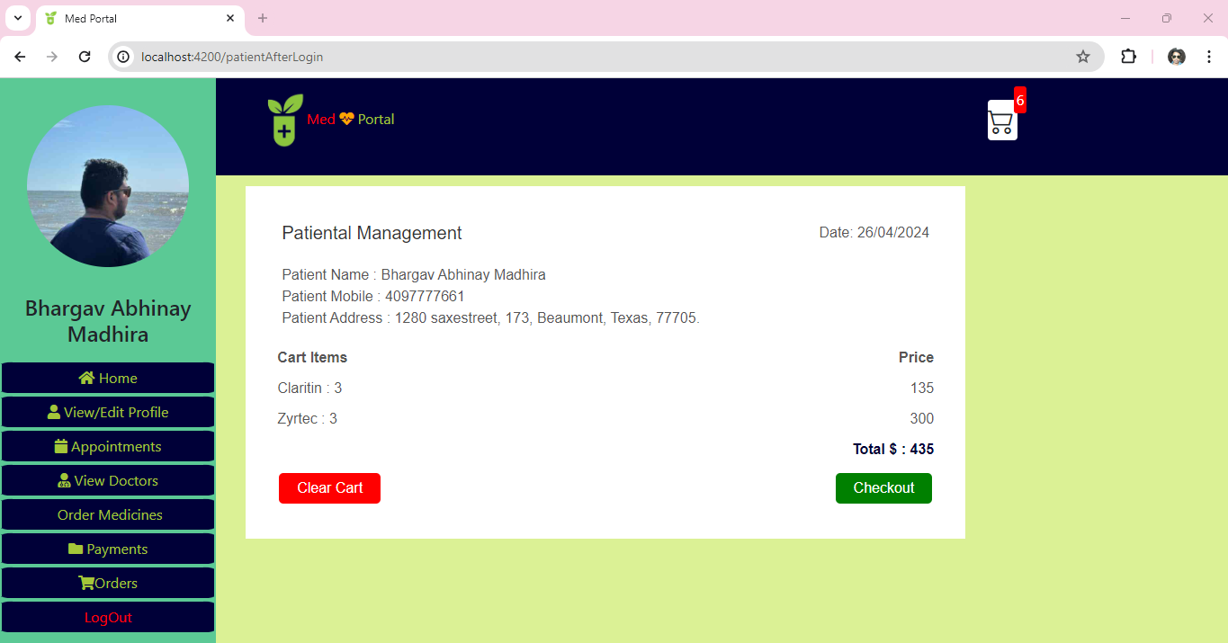

* Checkout the cart will redirect to the payment page. Once clicked with Pay Now Order will be placed.

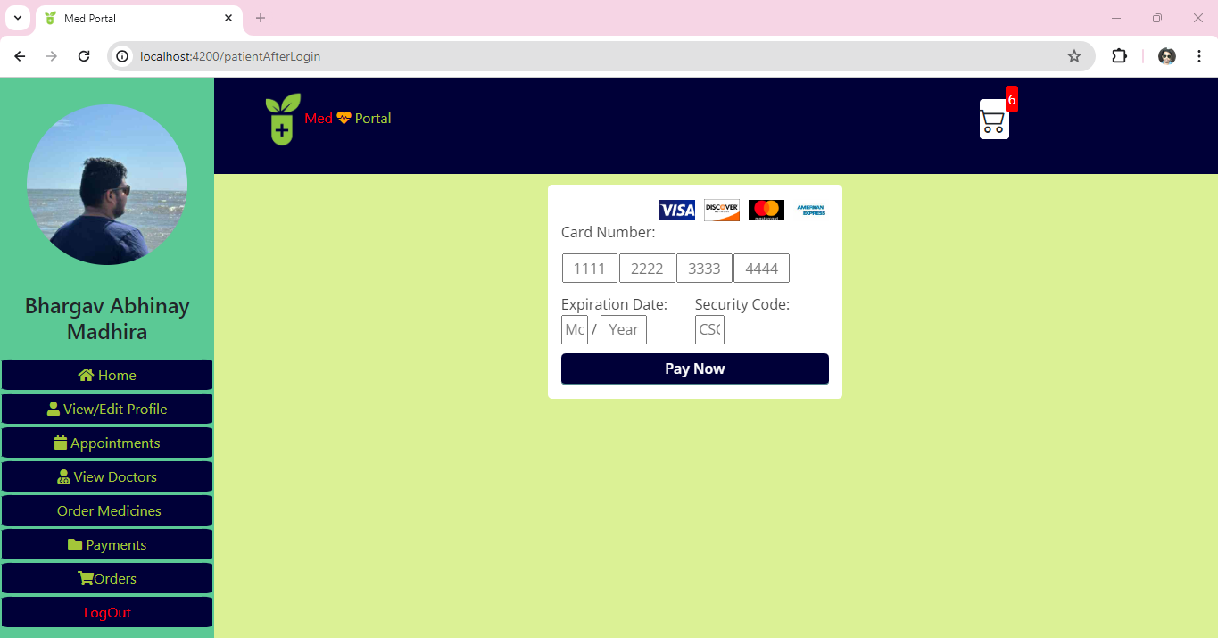

* Response of order placed successfully.

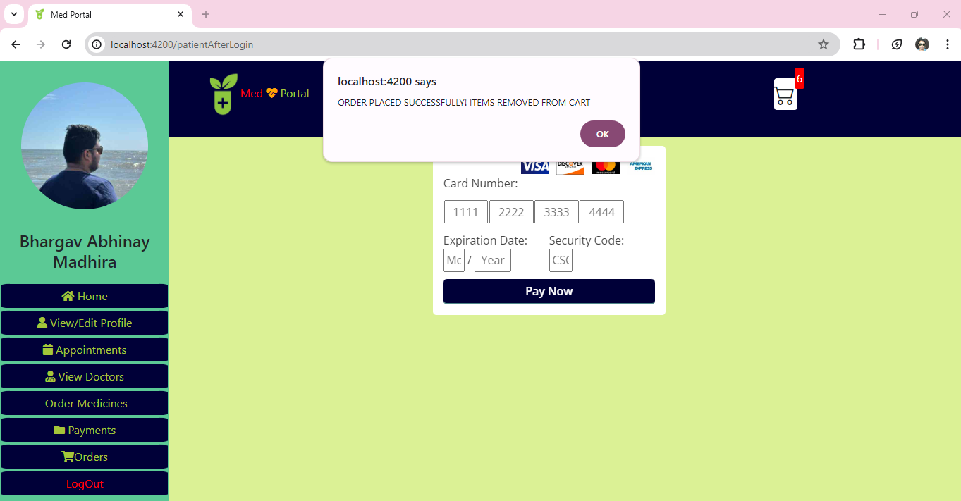

* Once the order is placed. The cart will be cleared automatically.

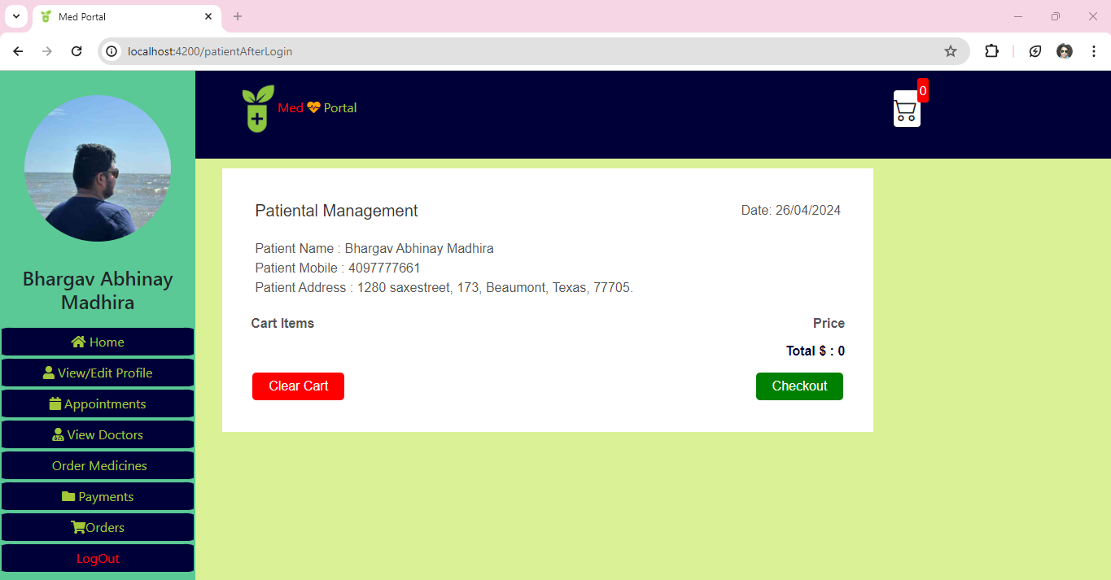

* We can View the Orders Placed.

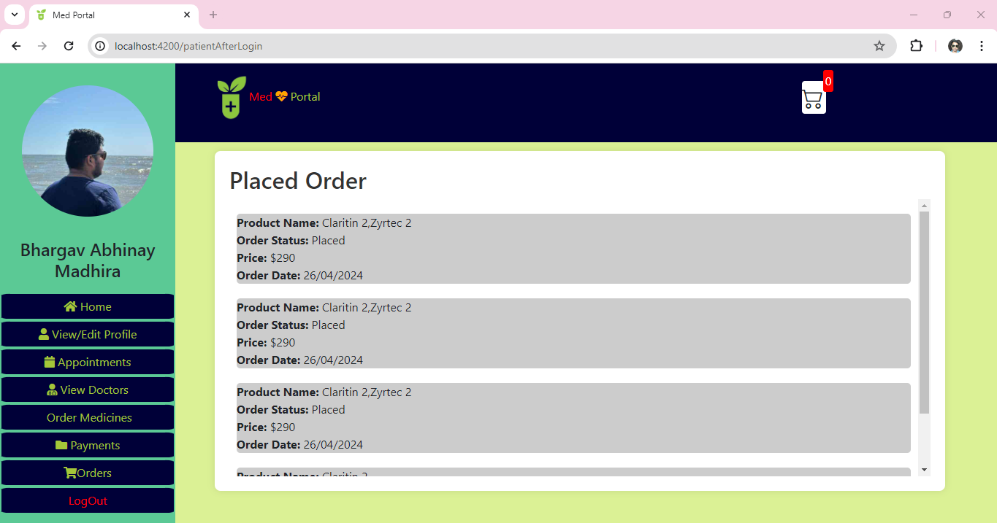

Hospital Management Portal

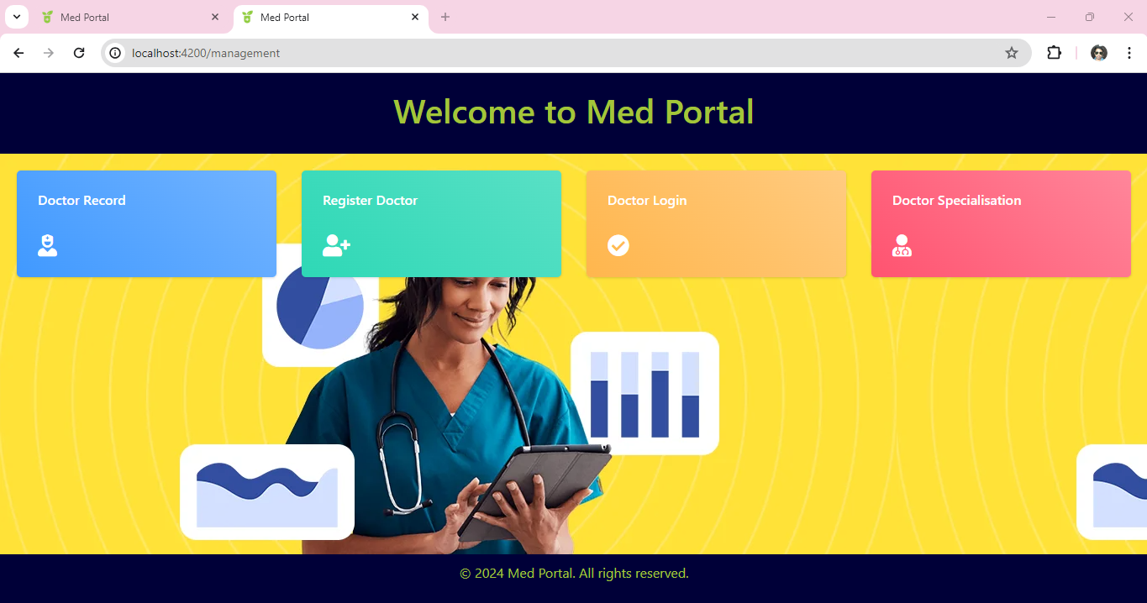

Doctor login

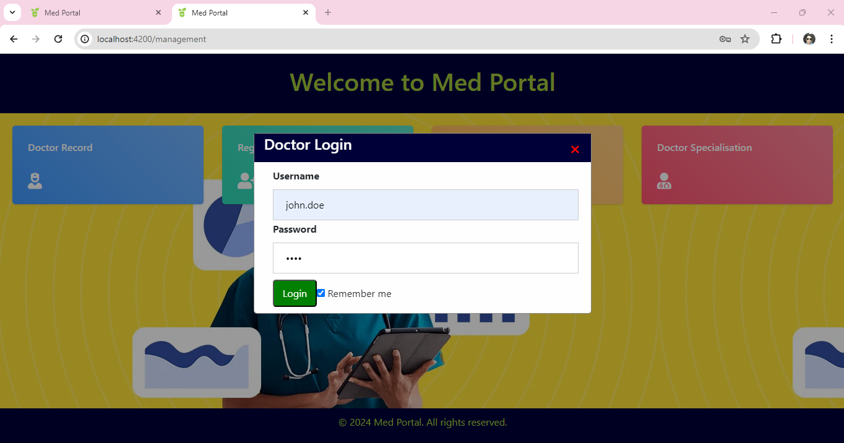

Doctor After Login

* A Doctor can be able to view the total Patients, check other doctors' specializations, and track daily appointments.

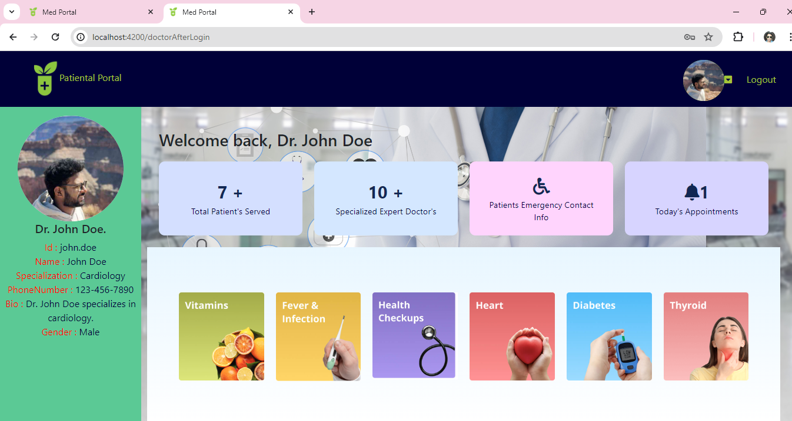

* He can edit his profile information, and change his password.

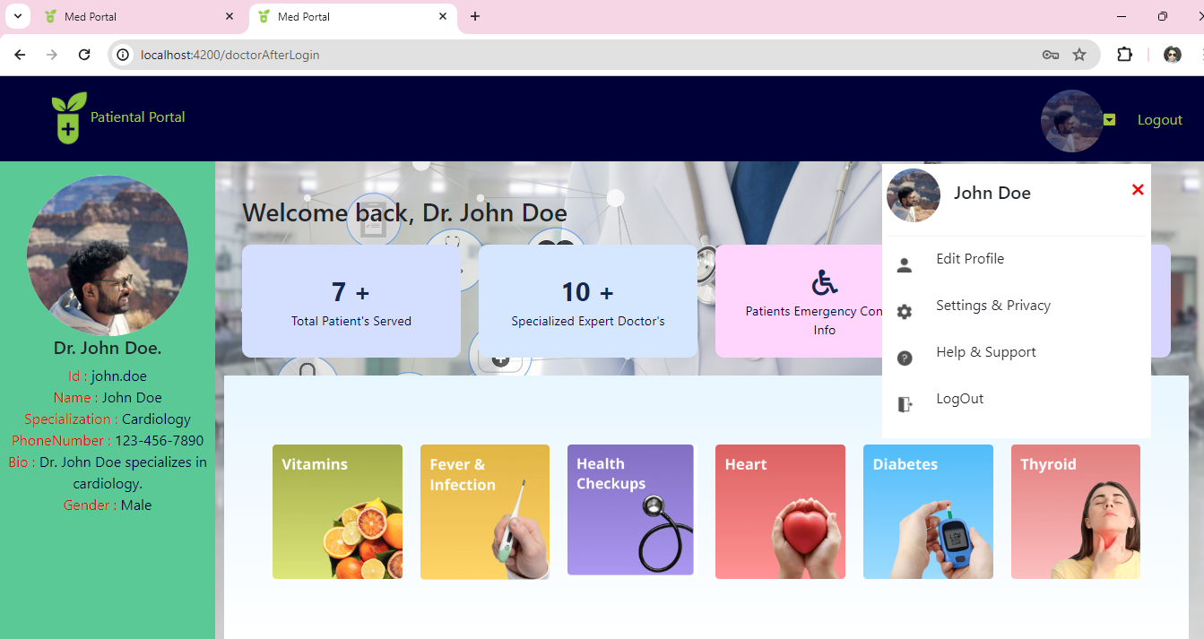

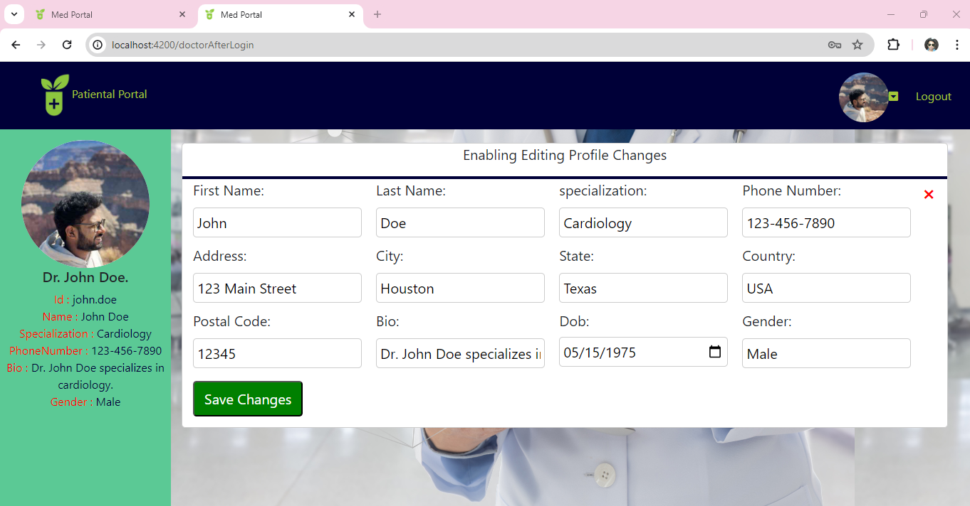

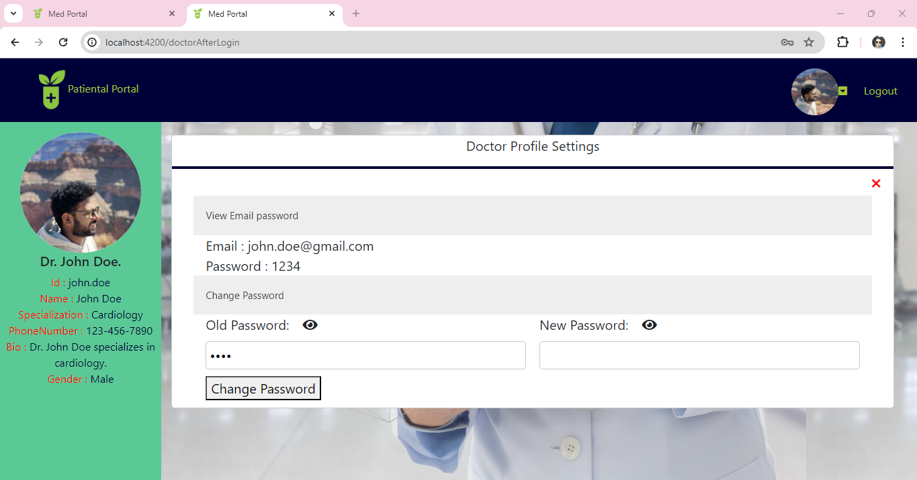

* View Patient Information

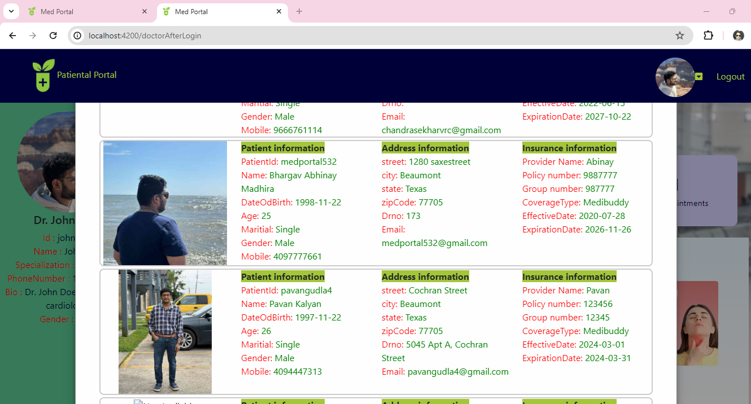

* View Doctors

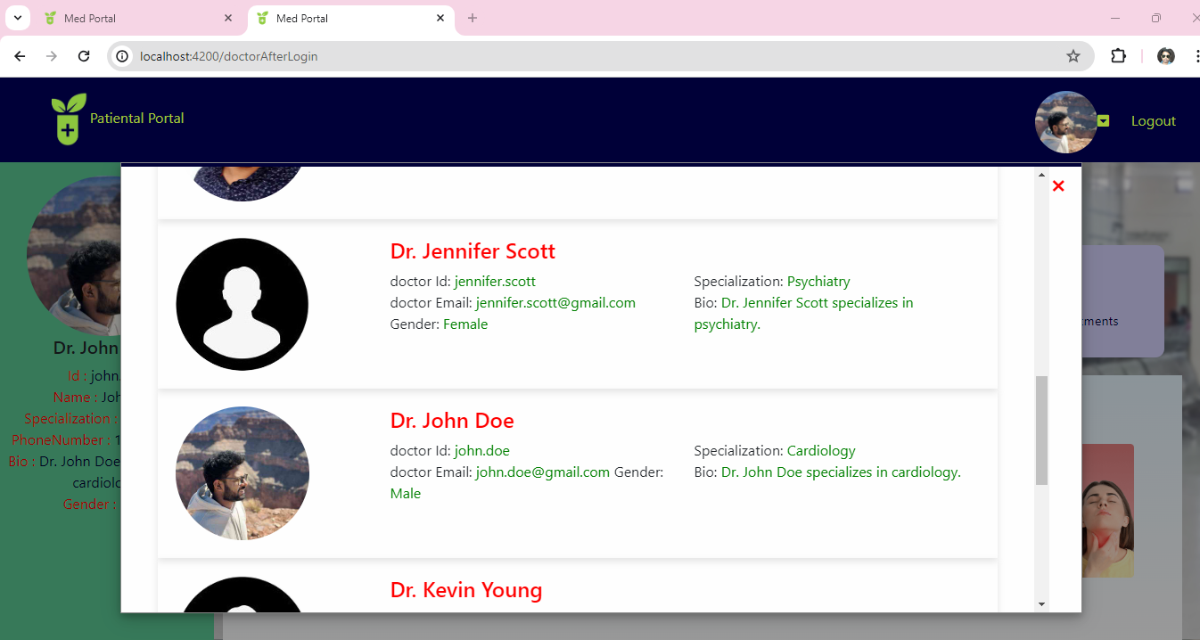

* View Patients Emergency Contact Informations

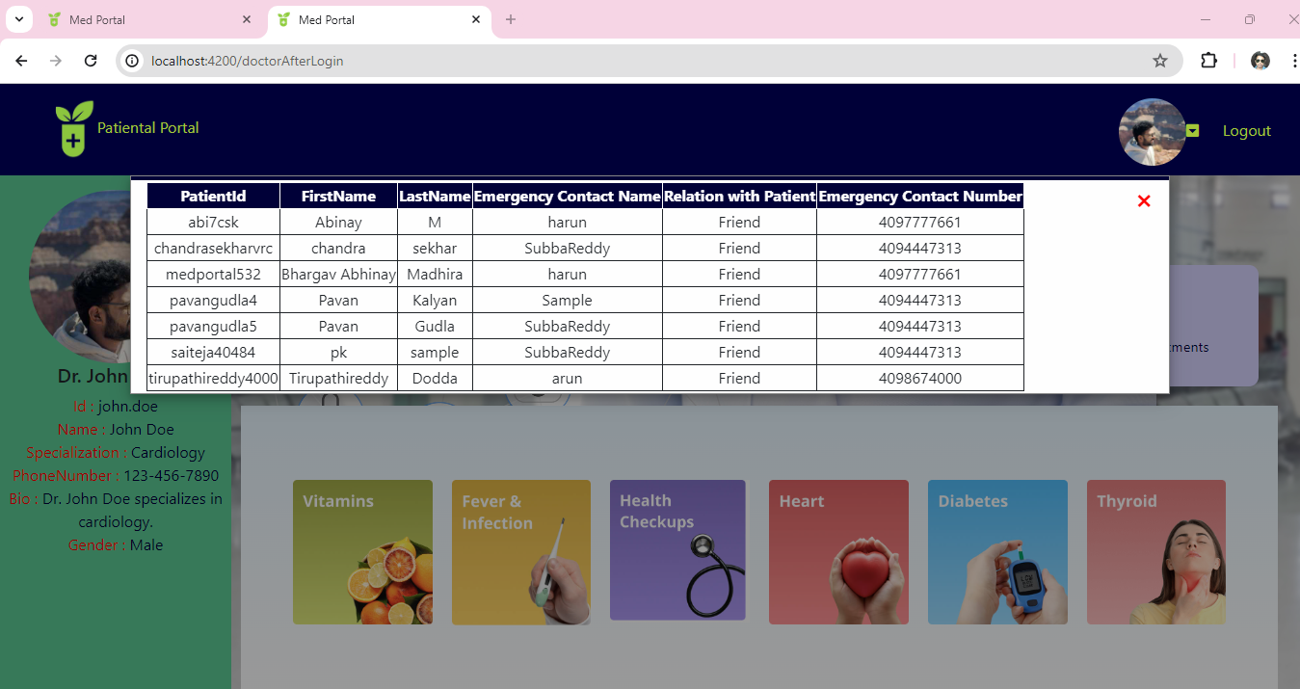

* Able to view Appointment Slots scheduled.

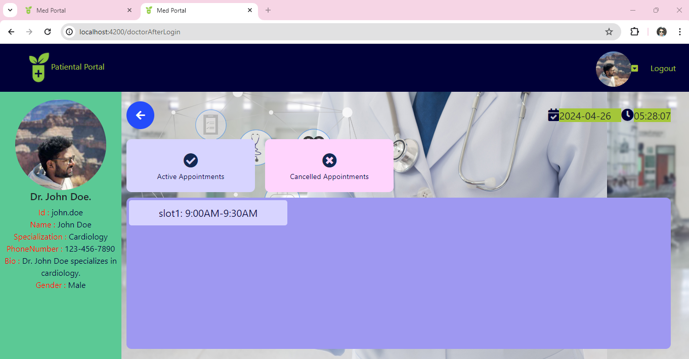

* Once the Patient is at your desk, you can investigate and prescribe medicines.

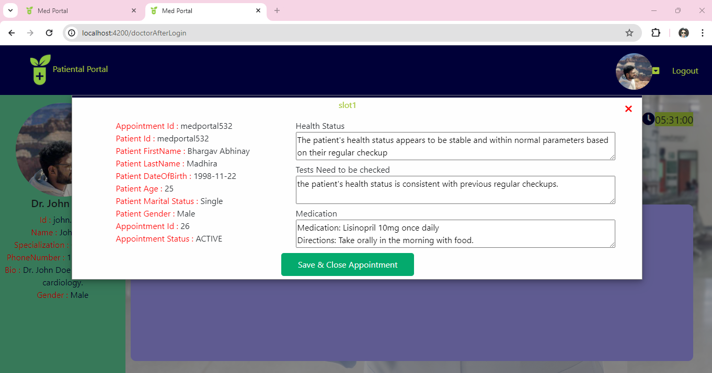

* Once the appointment is closed. It will be cleared and the patient can able to track it.

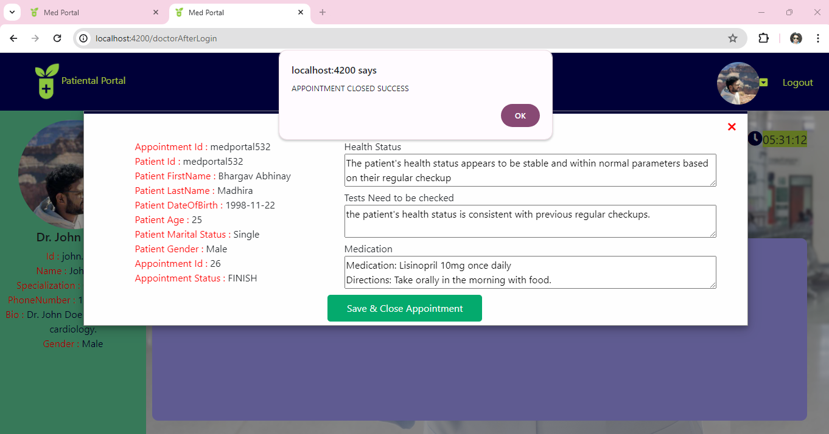

**TESTING**

Confirming and verifying the functionality of a software application or program is known as software testing.

Software testing makes sure that the program:

1. works as planned.

2. satisfies the technical and commercial requirements that guided its design and development.

Additionally, software testing finds important defects, vulnerabilities, or issues in application code that need to be fixed. The previous sentence's qualifier "important" is, well, significant because defects need to be categorized based on their severity.

We tested Our Application by Manual testing which includes end-to-end flows and API testing using the Postman Testing tool.

Understanding APIs: Before diving into testing, it's crucial to understand the APIs you're testing. This includes knowing the endpoints, request methods (GET, POST, PUT, DELETE, etc.), authentication mechanisms, expected responses, and error codes.

Testing Evidence:

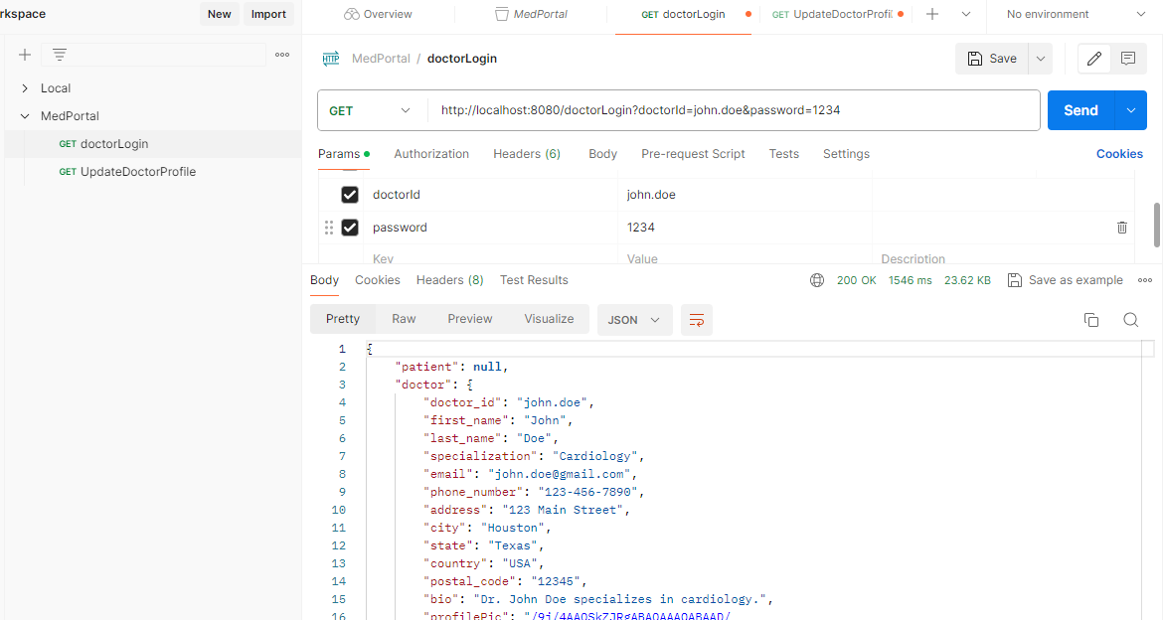

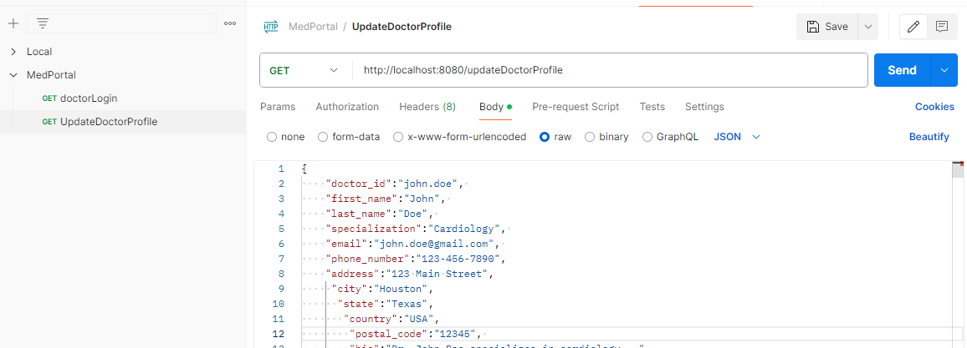

**Conclusion:**

Hence, we finally achieved the development, testing, and maintaining a Med Portal System and provided services to doctors and patients in their daily lives. This portal makes the Hospitals', and doctor's daily lives easy by providing all the main important services.

The Angular-powered Single Page Application Web portal is designed as a responsive and dynamic experience across a variety of devices.

**Future Work:**

* The Future work can include further development of including as many as possible services in this development architecture.
* HTTPS certificate to the backend service will provide APIs more secure.
* Based on the traffic of services and user growth if needed we can migrate the MySQL-related database to a NoSQL database like Mongo DB, this helps in API response time to respond faster.

Bibliography

* <https://www.javatpoint.com/spring-boot-tutorial>
* <https://angular.io/>
* <https://www.javatpoint.com/mysql-tutorial>
* <https://nodejs.org/en/download>